**YUM Server**

**Step-1**

Insert RHEL media and copy all dvd files in /rhel directory.

**[root@station1 ~]# mount**

/dev/sda2 on / type ext4 (rw)

proc on /proc type proc (rw)

sysfs on /sys type sysfs (rw)

devpts on /dev/pts type devpts (rw,gid=5,mode=620)

tmpfs on /dev/shm type tmpfs (rw,rootcontext="system_u:object_r:tmpfs_t:s0")

/dev/sda1 on /boot type ext4 (rw)

/dev/sda5 on /home type ext4 (rw)

none on /proc/sys/fs/binfmt_misc type binfmt_misc (rw)

sunrpc on /var/lib/nfs/rpc_pipefs type rpc_pipefs (rw)

gvfs-fuse-daemon on /root/.gvfs type fuse.gvfs-fuse-daemon (rw,nosuid,nodev)

/dev/sr0 on /media/RHEL_6.0 x86_64 Disc 1 type iso9660 (ro,nosuid,nodev,uhelper=udisks,uid=0,gid=0,iocharset=utf8,mode=0400,dmode=0500)

**[root@station1 ~]# mkdir /rhel**

**[root@station1 ~]# cd /media/**

**[root@station1 media]# ls**

RHEL_6.0 x86_64 Disc 1

**[root@station1 media]# cd RHEL_6.0\ x86_64\ Disc\ 1/**

**[root@station1 RHEL_6.0 x86_64 Disc 1]# ls**

**[root@station1 RHEL_6.0 x86_64 Disc 1]# cp -rvf * /rhel/[root@station1 ~]# cd**

**Step-2**

**[root@station1 ~]# cd /etc/yum.repos.d/**

**[root@station1 yum.repos.d]# ls**

**[root@station1 yum.repos.d]# vim server.repo**

[server]

name=This is yum server.

baseurl=file:///rhel

enabled=1

gpgcheck=0

**:wq (for save & exit)**

**[root@station1 yum.repos.d]# yum clean all**

yumLoaded plugins: refresh-packagekit, rhnplugin

Cleaning up Everything

**[root@station1 yum.repos.d]# yum list**

**[root@station1 yum.repos.d]# yum list all**

**[root@station1 ~]# yum install vsftpd* -y**

**[root@station1 ~]# yum info vsftpd**

**[root@station1 ~]# yum search vsftpd**

**[root@station1 ~]# yum list installed**

**[root@station1 ~]# yum remove vsftpd* -y**

**Step-3**

**How to create repodata file**

**[root@station1 ~]# cd /rhel/Packages/**

**[root@station1 Packages]# ls**

**# rpm -ivh createrepo-0.9.8-4.el6.noarch.rpm**

**warning:** createrepo-0.9.8-4.el6.noarch.rpm: Header V3 RSA/SHA256 Signature, key ID fd431d51: NOKEY

error: Failed dependencies:

deltarpm is needed by createrepo-0.9.8-4.el6.noarch

python-deltarpm is needed by createrepo-0.9.8-4.el6.noarch

**# rpm -ivh deltarpm-3.5-0.5.20090913git.el6.x86_64.rpm**

**warning:** deltarpm-3.5-0.5.20090913git.el6.x86_64.rpm: Header V3 RSA/SHA256 Signature, key ID fd431d51: NOKEY

Preparing... ########################################### [100%]

1:deltarpm ########################################### [100%]

**# rpm -ivh python-deltarpm-3.5-0.5.20090913git.el6.x86_64.rpm**

**warning:** python-deltarpm-3.5-0.5.20090913git.el6.x86_64.rpm: Header V3 RSA/SHA256 Signature, key ID fd431d51: NOKEY

Preparing... ########################################### [100%]

1:python-deltarpm ########################################### [100%]

**# rpm -ivh createrepo-0.9.8-4.el6.noarch.rpm**

**warning:** createrepo-0.9.8-4.el6.noarch.rpm: Header V3 RSA/SHA256 Signature, key ID fd431d51: NOKEY

Preparing... ########################################### [100%]

1:createrepo ########################################### [100%]

**[root@station1 Packages]# cd**

**[root@station1 ~]# createrepo -v /rhel/Packages**

**[root@station1 yum.repos.d]# yum clean all**

yumLoaded plugins: refresh-packagekit, rhnplugin

Cleaning up Everything

**[root@station1 yum.repos.d]# yum list**

**[root@station1 yum.repos.d]# yum list all**

################################################

**YUM Client Configuration in LAB Setup:-**

How to configure YUM Client by using FTP Server

**[root@station1 ~]# cd /etc/yum.repos.d/**

**[root@station1 yum.repos.d]# ls**

**[root@station1 yum.repos.d]# vim client.repo**

[client]

name=This is yum ftp client.

baseurl=ftp://192.168.0.254/pub/rhel6/dvd

enabled=1

gpgcheck=0

**:wq**

**[root@station1 yum.repos.d]# yum clean all**

yumLoaded plugins: refresh-packagekit, rhnplugin

Cleaning up Everything

**[root@station1 yum.repos.d]# yum list**

**[root@station1 yum.repos.d]# yum list all**

**[root@station1 ~]# yum install vsftpd* -y**

**[root@station1 ~]# yum info vsftpd**

**[root@station1 ~]# yum search vsftpd**

**[root@station1 ~]# yum list installed**

**[root@station1 ~]# yum remove vsftpd* -y**

################################################

**NFS Server**

**Step-1**

**[root@station2 ~]# rpm -qa nfs\***

nfs4-acl-tools-0.3.3-5.el6.x86_64

nfs-utils-1.2.2-7.el6.x86_64

nfs-utils-lib-1.1.5-1.el6.x86_64

**[root@station2 ~]# mkdir /rhel**

**[root@station2 ~]# cd /rhel/**

**[root@station2 rhel]# touch a{1,2,3,4,5}**

**[root@station2 rhel]# cd**

**[root@station2 ~]# mkdir /rhelread**

**[root@station2 ~]# cd /rhelread**

**[root@station2 rhel]# touch b{1,2,3,4,5}**

**[root@station2 ~]# chmod 777 /rhel**

**[root@station2 ~]# chmod 777 /rhelread**

**Step-2**

**[root@station2 ~]# vim /etc/exports**

/rhel *(rw,sync)

/rhelread 192.168.0.0/255.255.255.0(ro,async)

**:wq**

**[root@station2 ~]# service nfs restart**

**[root@station2 ~]# chkconfig nfs on**

**[root@station2 ~]# service portmap restart**

{suport only in RHEL-5}

**[root@station2 ~]# chkconfig portmap on**

{suport only in RHEL-5}

**[root@station2 ~]# service portreserve restart**

{New in RHEL-6}

**[root@station2 ~]# chkconfig portreserve on**

**[root@station2 ~]# exportfs -v**

**[root@station2 ~]# exportfs -r**

**[root@station2 ~]# rpcinfo -p**

**[root@station2 ~]# showmount -e**

**[root@station2 ~]# showmount -e 192.168.0.10**

**[root@station2 ~]# service iptables stop**

**[root@station2 ~]# chkconfig iptables off**

**NFS Client Configuration:-**

**NIS Server**

**Step-1**

**[root@station1 ~]# mkdir /rhome**

**useradd -d /rhome/nisuser1 nisuser1**

**useradd -d /rhome/nisuser2 nisuser2**

**useradd -d /rhome/nisuser3 nisuser3**

**[root@station1 ~]# passwd nisuser1**

**[root@station1 ~]# passwd nisuser2**

**[root@station1 ~]# passwd nisuser3**

**Step-2**

**[root@station1 ~]# nisdomainname**

(none)

**[root@station1 ~]# nisdomainname RHCE**

**[root@station1 ~]# nisdomainname**

RHCE

**[root@station1 ~]# vim /etc/sysconfig/network**

NETWORKING=yes

NETWORKING_IPV6=no

HOSTNAME=station1.example.com

NISDOMAIN=RHCE

YPSERV_ARGS="-p 808"

**:wq**

**Step-3**

**[root@station1 ~]# yum install yp* -y**

**[root@station1 ~]# service ypserv restart**

Stopping YP server services: [ OK ]

Starting YP server services: [ OK ]

**[root@station1 ~]# chkconfig ypserv on**

**[root@station1 ~]# /usr/lib/yp/ypinit -m**

next host to add: station1.example.com

next host to add:

Press **ctrl + D** (save & Exit)

The current list of NIS servers looks like this: station1.example.com

Is this correct? [y/n: y] **y (Press Y)**

**station1.example.com** has been set up as a **NIS master server**

**Step-4**

**[root@station1 ~ ]# cd /var/yp/**

**[root@station1 yp]# ls**

binding Makefile nicknames RHCE ypservers

**[root@station1 yp]# make**

gmake[1]: Entering directory `/var/yp/RHCE'

Updating netid.byname...

gmake[1]: Leaving directory `/var/yp/RHCE'

**[root@station1 ~]# rpcinfo -p**

**Step-5**

**[root@station1 ~]# vim /etc/exports**

/rhome *(rw,sync)

**:wq**

**[root@station1 ~]# service nfs restart**

[**root@station1 ~]# chkconfig nfs on**

**[root@station1 ~]# service portmap restart** {In RHEL5}

**[root@station1 ~]# chkconfig portmap on** {In RHEL5}

**[root@station1 ~]# service portreserve restart** {In RHEL6}

**[root@station1 ~]# chkconfig portreserve on** {In RHEL6}

**[root@station1 ~]# service iptables stop**

**[root@station1 ~]#chkconfig iptables off**

################now server is ready#################

**NIS Client Configuration:-**

**EFS Server**

**[root@station1 ~]# yum install crypt* -y**

**[root@station1 ~]# fdisk -l /dev/sda**

**[root@station1 ~]# fdisk -c /dev/sda**

Command (m for help): **n**

First cylinder (1811-2611, default 1811): **Enter**

Using default value 1811

Last cylinder, +cylinders or +size{K,M,G} (1811-2611, default 2611): **+500M**

Command (m for help): **w**

**[root@station1 ~]# partx -a /dev/sda**

**[root@station1 ~]# partx -a /dev/sda**

**cryptsetup luksFormat /dev/sda6**

**WARNING!**

========

This will overwrite data on /dev/sda6 irrevocably.

Are you sure? (Type uppercase yes): YES

Enter LUKS passphrase:

Verify passphrase:

**cryptsetup luksOpen /dev/sda6**

storage

Enter passphrase for /dev/sda6:

**[root@station1 ~]# ll /dev/mapper/**

total 0

crw-rw----. 1 root root 10, 58 Nov 26 08:29 control

lrwxrwxrwx. 1 root root 7 Nov 26 09:16 storage -> ../dm-0

**[root@station1 ~]# mkfs.ext4 /dev/mapper/storage**

**[root@station1 ~]# mkdir /crypt**

**[root@station1 ~]# mount /dev/mapper/storage /crypt/**

**[root@station1 ~]# vim /etc/fstab**

/dev/mapper/storage /crypt ext4 defaults 0 0

**:wq**

**#mount -a**

**#mount**

**#df -TH**

**#du -sh /crypt**

**#cd /crypt**

**#ls**

**#mkdir data**

**#ls**

**#cd**

**#vim /etc/crypttab**

storage /dev/sda6

**:wq**

**#reboot**

it will prompt for password.

**Swap**

**[root@station1 ~]# fdisk -c /dev/sda**

Command (m for help): n

First cylinder (1671-2610, default 1671): press Blank Enter

Using default value 1671

Last cylinder or +size or +sizeM or +sizeK (1671-2610, default 2610): +2G (twice of RAM size)

Command (m for help): t

Partition number (1-6): 6

Hex code (type L to list codes): 82

Changed system type of partition 6 to 82 (Linux swap / Solaris)

Command (m for help): p

Command (m for help): w

**[root@station1 ~]# partx -a /dev/sda**

**[root@station1 ~]# partx -a /dev/sda**

**[root@station1 ~]#mkswap /dev/sda5**

Setting up swapspace version 1, size = 2006929 kB

**[root@station1 ~]# swapon /dev/sda5**

**[root@station1 ~]# swapon -s**

Filename Type Size Used Priority

/dev/sda3 partition 3068404 0 -1

/dev/sda5 partition 1959888 0 -2

**[root@station1 ~]# vim /etc/fstab**

/dev/sda5 swap swap defaults 0 0

**:wq!**

**[root@station1 ~]# mount -a**

**[root@station1 ~]# free -m -t**

total used free shared buffers cached

Mem: 1431 758 673 0 36 566

-/+ buffers/cache: 155 1275

Swap: 4910 0 4910

Total: 6342 758 5583

**[root@station1 ~]# cat /proc/swaps**

**Creating a swap file**

#swapoff –a

# cd /

#dd if=/dev/zero of=swapfile bs=512M count=1

#mkswap –v1 /swapfile

Add an entry in the /etc/rc.local

#vi /etc/rc.local

Swapon /swapfile

**:wq!**

# reboot -f

# swapon -s

**Partition**

**[root@station1 ~]# fdisk -l**

Disk /dev/sda: 21.4 GB, 21474836480 bytes

255 heads, 63 sectors/track, 2610 cylinders

Units = cylinders of 16065 * 512 = 8225280 bytes

Device Boot Start End Blocks Id System

/dev/sda1 * 1 13 104391 83 Linux

/dev/sda2 14 1288 10241437+ 83 Linux

/dev/sda3 1289 1670 3068415 82 Linux swap / Solaris

**[root@station1 ~]# fdisk /dev/sda**

Command (m for help): n

Command action

e extended

p primary partition (1-4)

e

Selected partition 4

First cylinder (1671-2610, default 1671):

Using default value 1671

Last cylinder or +size or +sizeM or +sizeK (1671-2610, default 2610):

Using default value 2610

Command (m for help): n

First cylinder (1671-2610, default 1671):

Using default value 1671

Last cylinder or +size or +sizeM or +sizeK (1671-2610, default 2610): +200M

Command (m for help): p

Command (m for help): w

**partx -a /dev/sda (2 times)**

**[root@station1 ~]# mkfs.ext4 /dev/sda5**

**[root@station1 ~]# mkdir /data**

**[root@station1 ~]# mount /dev/sda5 /data/**

**[root@station1 ~]# cd /data**

**[root@station1 data]# touch abc{1..10}**

**[root@station1 data]# ls**

**[root@station1 ~]# cd**

**[root@station1 ~]# vim /etc/fstab/**

dev/sda5 /data ext4 defaults 0 0

**:wq!**

**[root@station1 ~]# mount -a**

**[root@station1 ~]# mount**

**/dev/sda5 on /data type ext4 (rw)**

**[root@station1 ~]# df -TH**

**[root@station1 ~]# umount /data**

**[root@station1 ~]# vim /etc/fstab**

dev/sda5 /data ext4 defaults 0 0

press dd

**:wq!**

**[root@station1 ~]# mount –a**

**[root@station1 ~]# cd /data**

**[root@station1 ~]# ls**

**Crontab**

**[root@station1 ~]# crontab -l**

no crontab for root

**[root@station1 ~]# vim /etc/crontab**

**[root@station1 ~]# crontab -e**

05 15 * * * /bin/echo "hello boys"

**:wq!**

**[root@station1 ~]# crontab –e**

no crontab for root - using an empty one

crontab: installing new crontab

**[root@station1 ~]#service crond restart**

**[root@station1 ~]# chkconfig crond on**

**[root@station1 ~]# crontab -l**

05 15 * * * /sbin/reboot

* * * * * /bin/echo "hello girls"

**[root@station1 ~]# mail**

**[root@station1 ~]# crontab -r**

**[root@station1 ~]# useradd krishna**

**[root@station1 ~]# passwd krishna**

**[root@station1 ~]# crontab -e -u krishna**

05 15 * * * /bin/echo "hello boys how r u!"

**:wq!**

**[root@station1 ~]#service crond restart**

**[root@station1 ~]# chkconfig crond on**

**[root@station1 ~]#su - kishna**

**[krishna@station1 ~]$mail**

**[krishna@station1 ~]$exit**

**[root@station1 ~]# cd /var/spool/cron**

**[root@station1 cron]# ls**

krishna root

**[root@station1 cron]# cd**

**[root@station1 ~]# crontab -l -u krishna**

**[root@station1 ~]# crontab -r -u krishnad**

**[root@station1 ~]# tail -f /var/log/cron**

Apr 5 04:27:01 localhost crond[17362]: (root) CMD (/bin/echo "hello girls")

Apr 5 04:27:01 localhost crond[17364]: (krishna) CMD (/bin/echo "hello boys how r u!")

Apr 5 04:28:01 localhost crond[17376]: (root) CMD (/bin/echo "hello girls")

Apr 5 04:33:10 localhost crontab[17461]: (root) DELETE (root)

Apr 5 04:33:15 localhost crontab[17462]: (root) DELETE (krishna)

**[root@station1 ~]# vim backup.sh**

rsync -avH /var/log/secure /root

**:wq!**

**[root@station1 ~]# crontab -e**

* * * * * /bin/sh /root/backup.sh

**:wq!**

**[root@station1 ~]# service crond restart**

**[root@station1 ~]# chkconfig crond on**

**[root@station1 ~]# ls**

**[root@station1 ~]# vim /etc/cron.deny**

krishna

ram

shyam

**:wq!**

**[root@station1 ~]#**

**KVM**

**[root@krnetworkcloud ~]# yum install qemu* virt* -y**

**[root@krnetworkcloud ~]# yum install libvirt* -y**

**[root@krnetworkcloud ~]# service libvirtd restart**

Stopping libvirtd daemon: [ OK ]

Starting libvirtd daemon: [ OK ]

**[root@krnetworkcloud ~]# chkconfig libvirtd on**

**[root@krnetworkcloud ~]# fdisk -l /dev/sda**

Disk /dev/sda: 250.1 GB, 250059350016 bytes

255 heads, 63 sectors/track, 30401 cylinders

Units = cylinders of 16065 * 512 = 8225280 bytes

Sector size (logical/physical): 512 bytes / 512 bytes

I/O size (minimum/optimal): 512 bytes / 512 bytes

Disk identifier: 0x0004840a

Device Boot Start End Blocks Id System

/dev/sda1 * 1 13 102400 83 Linux

Partition 1 does not end on cylinder boundary.

/dev/sda2 13 3583 28672000 8e Linux LVM

/dev/sda3 3583 3648 524288 82 Linux swap / Solaris

**[root@krnetworkcloud ~]# fdisk -c /dev/sda**

**WARNING:** cylinders as display units are deprecated. Use command 'u' to

change units to sectors.

Command (m for help): n

Command action

e extended

p primary partition (1-4)

e

Selected partition 4

First cylinder (3648-30401, default 3648):

Using default value 3648

Last cylinder, +cylinders or +size{K,M,G} (3648-30401, default 30401):

Using default value 30401

Command (m for help): n

First cylinder (3648-30401, default 3648):

Using default value 3648

Last cylinder, +cylinders or +size{K,M,G} (3648-30401, default 30401): +20G

Command (m for help): w

The partition table has been altered!

Calling ioctl() to re-read partition table.

**WARNING**: Re-reading the partition table failed with error 16: Device or resource busy.

The kernel still uses the old table. The new table will be used at

the next reboot or after you run partprobe(8) or kpartx(8)

Syncing disks.

**[root@krnetworkcloud ~]# partx -a /dev/sda**

**[root@krnetworkcloud ~]# partx -a /dev/sda**

**[root@krnetworkcloud ~]# virt-manager&**

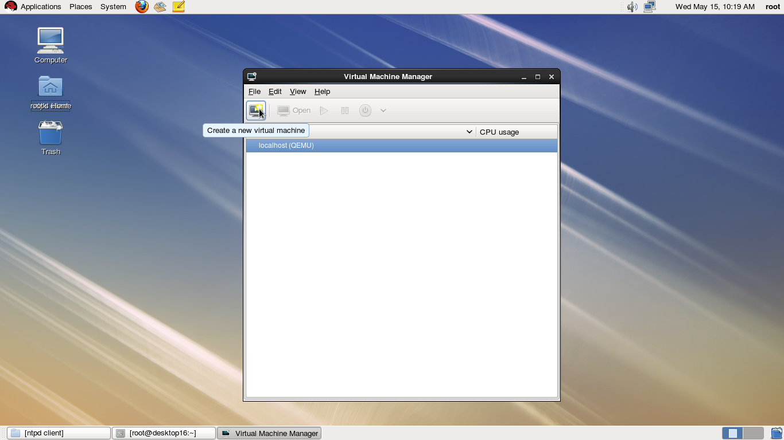

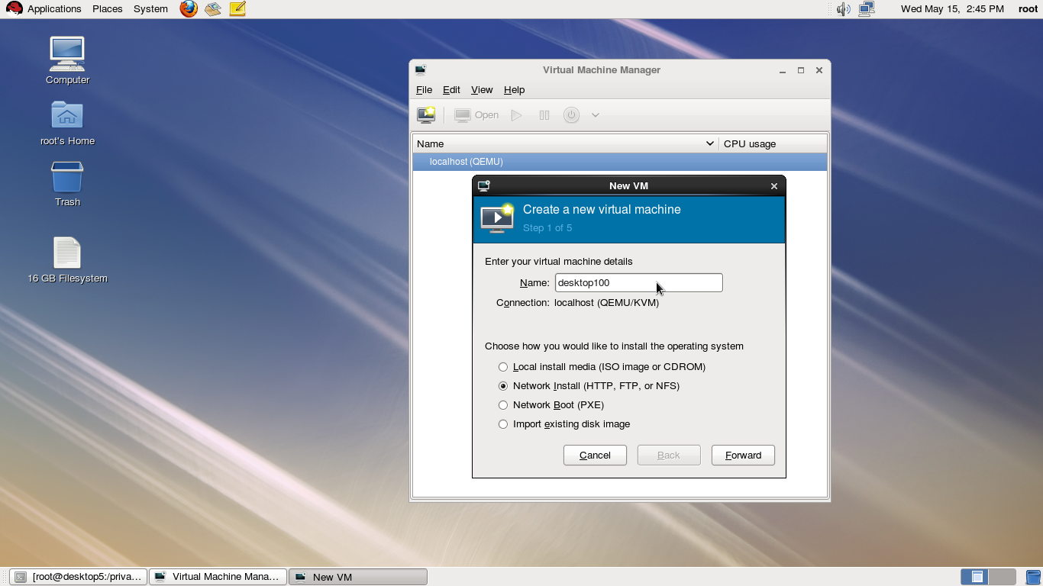

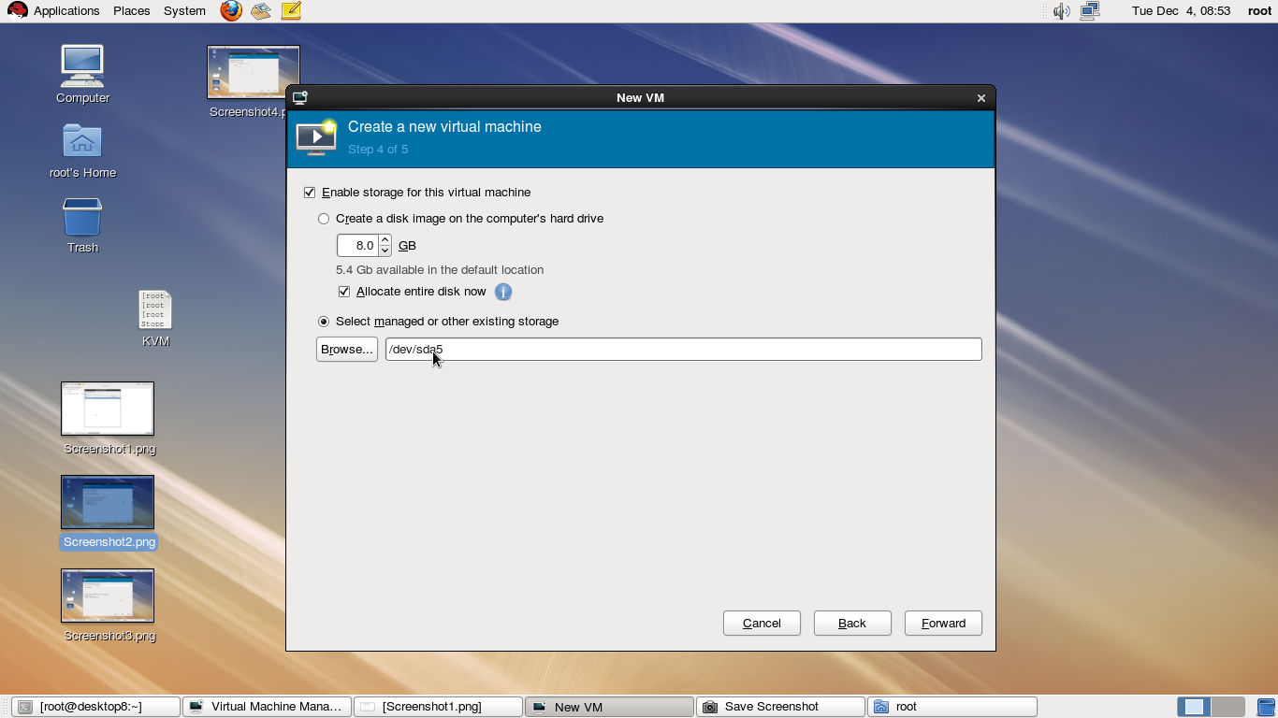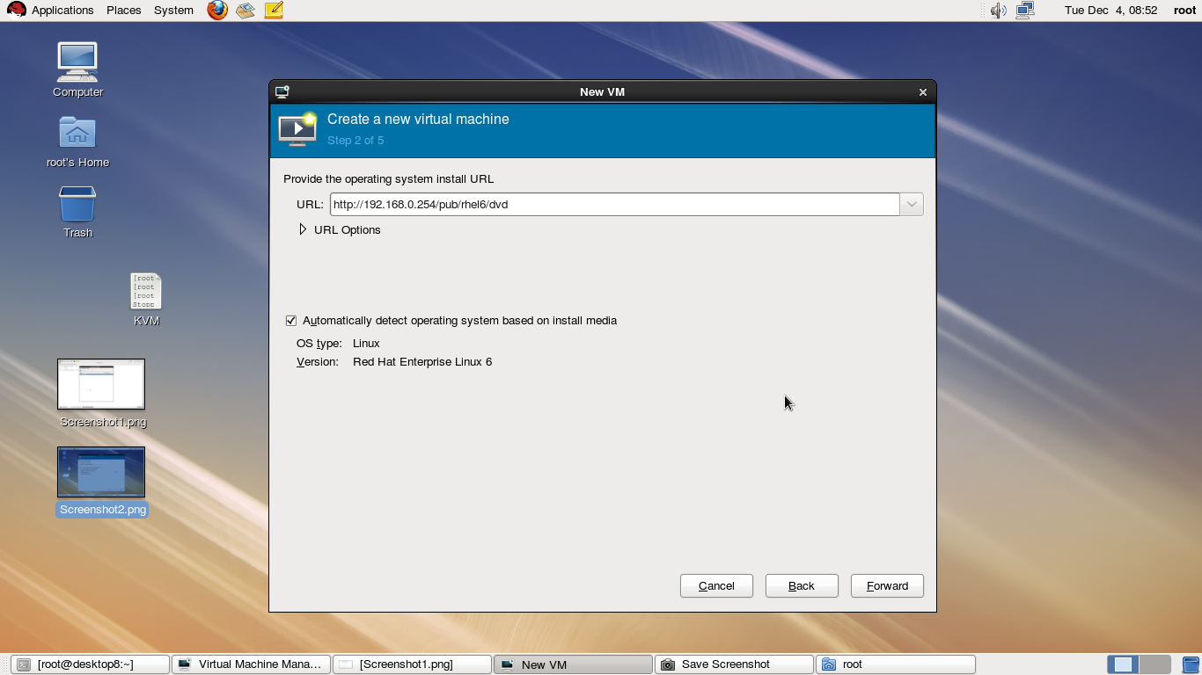

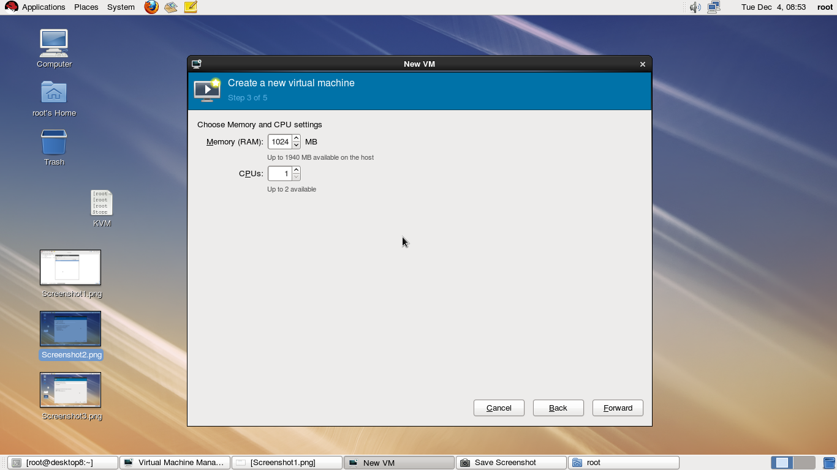

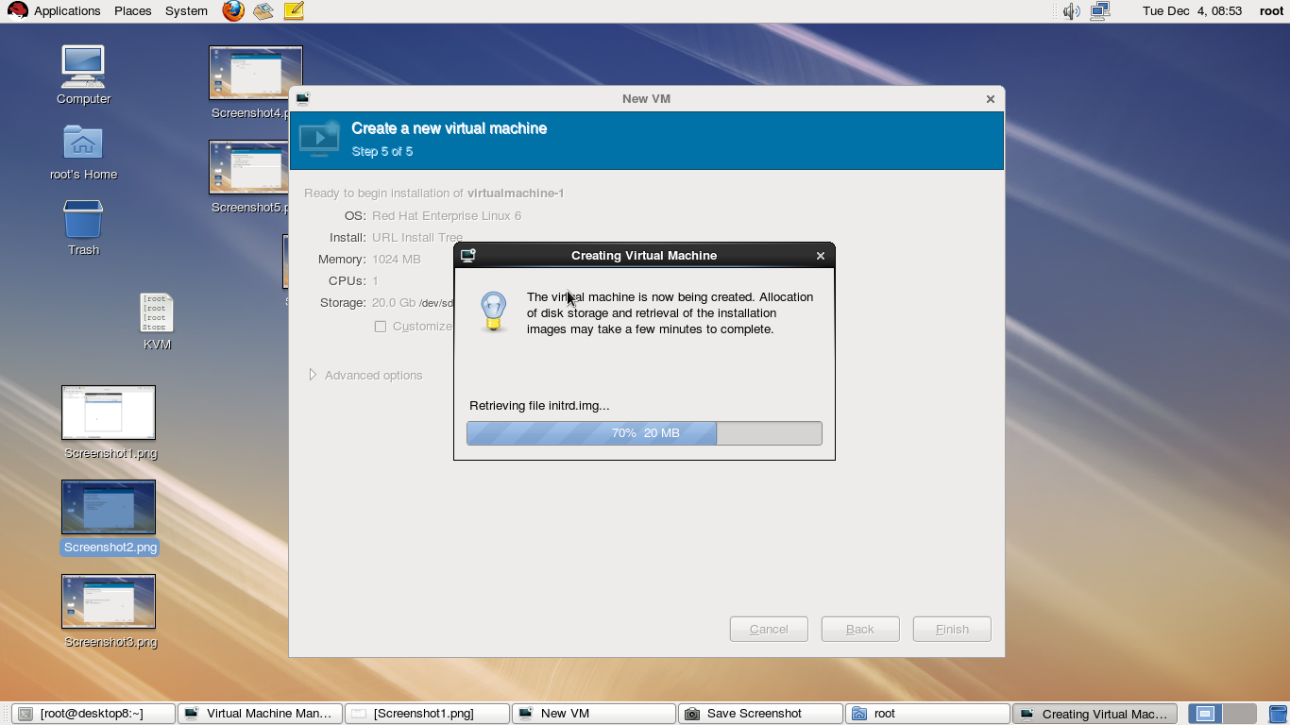

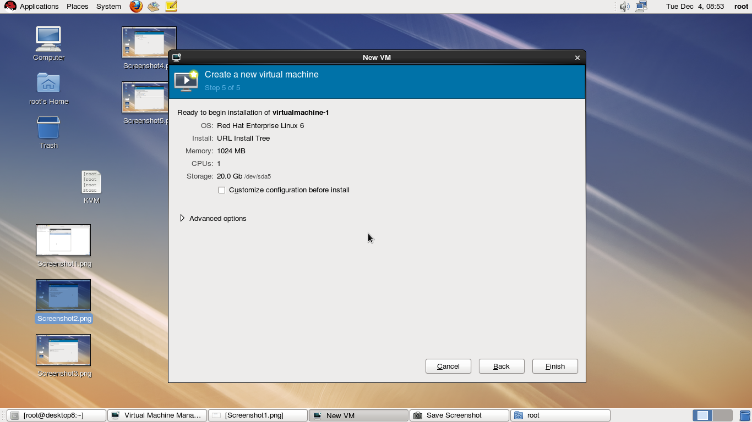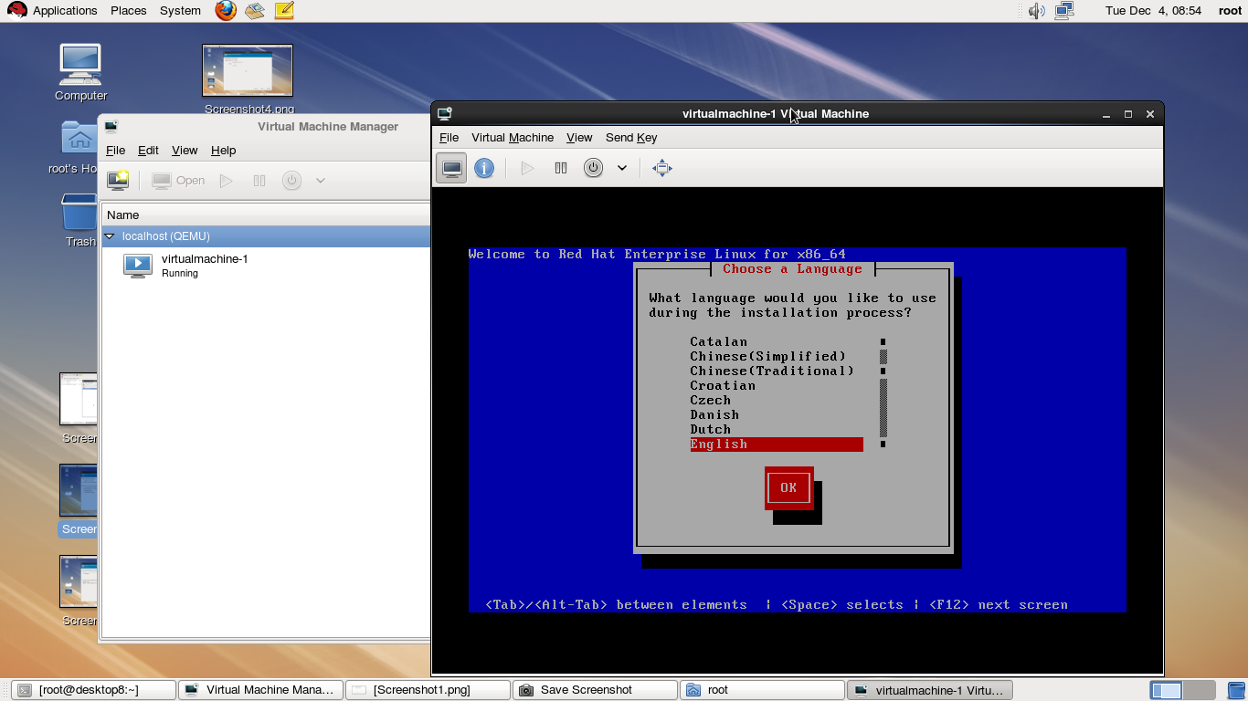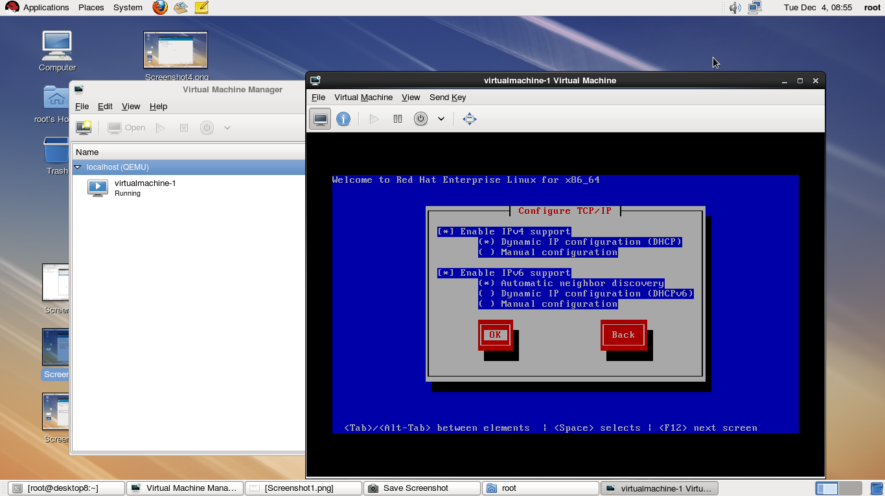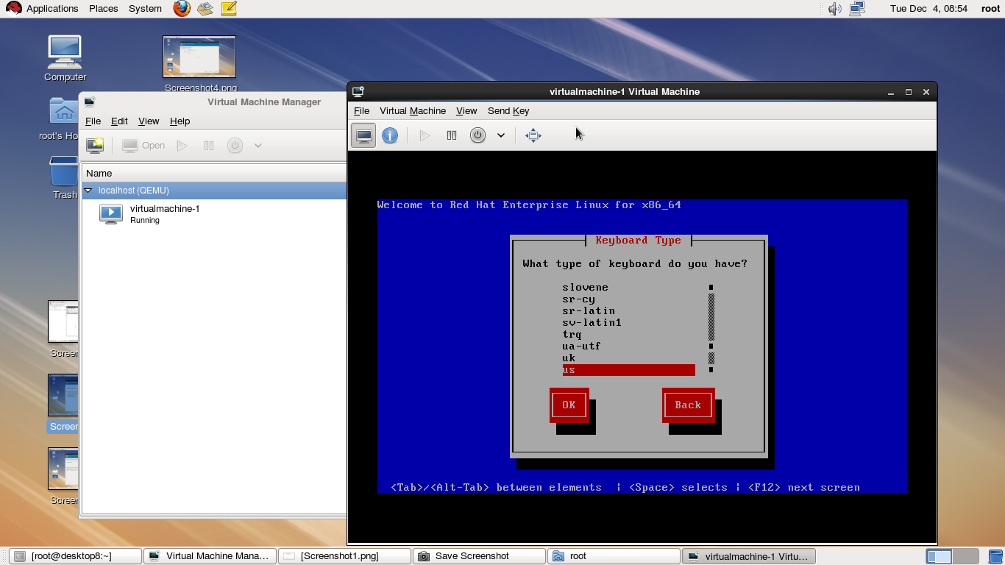

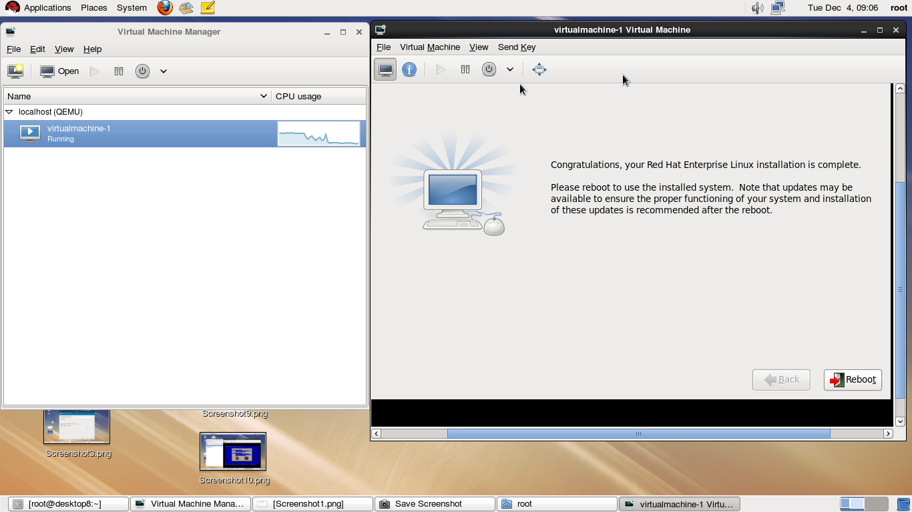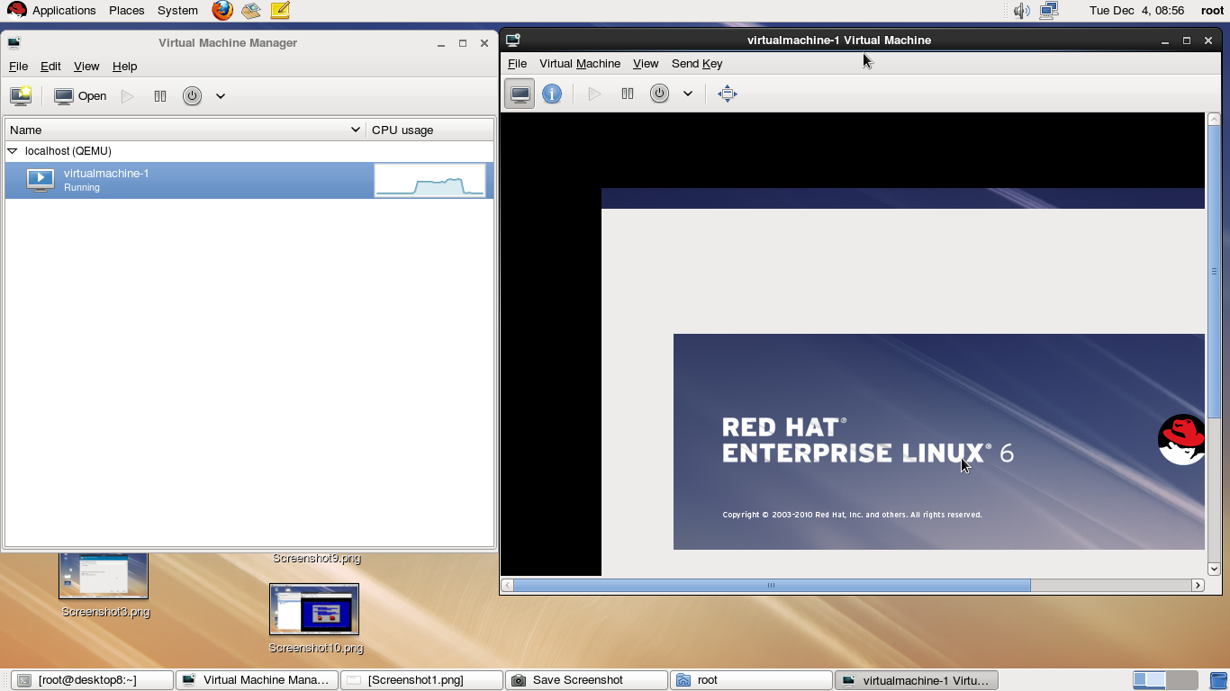

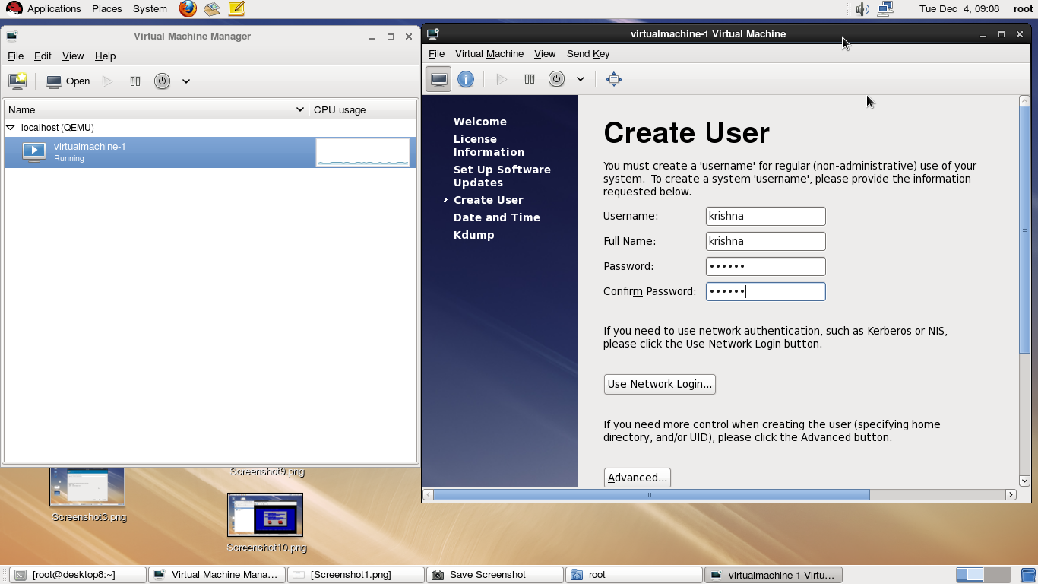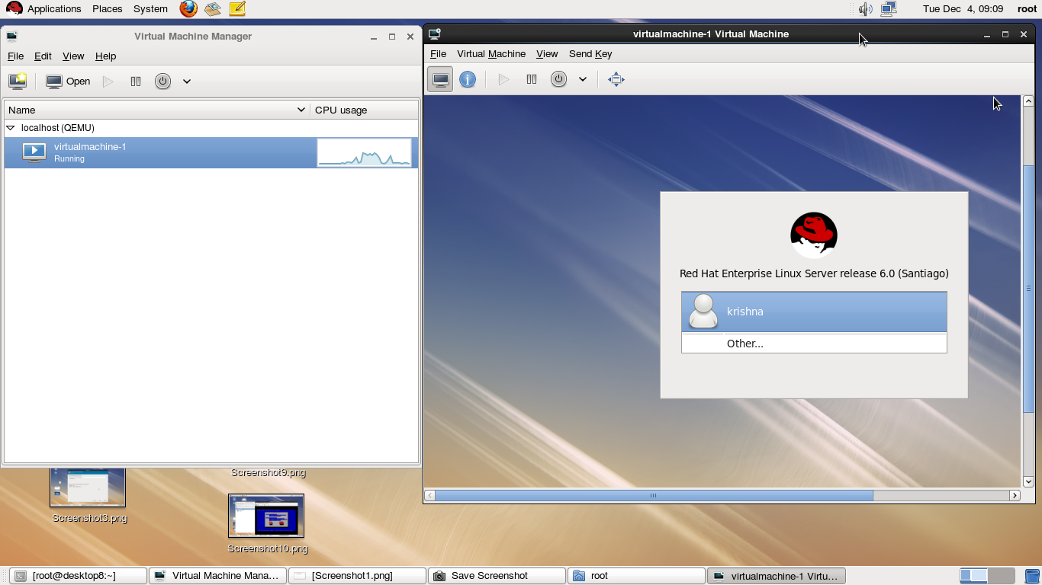

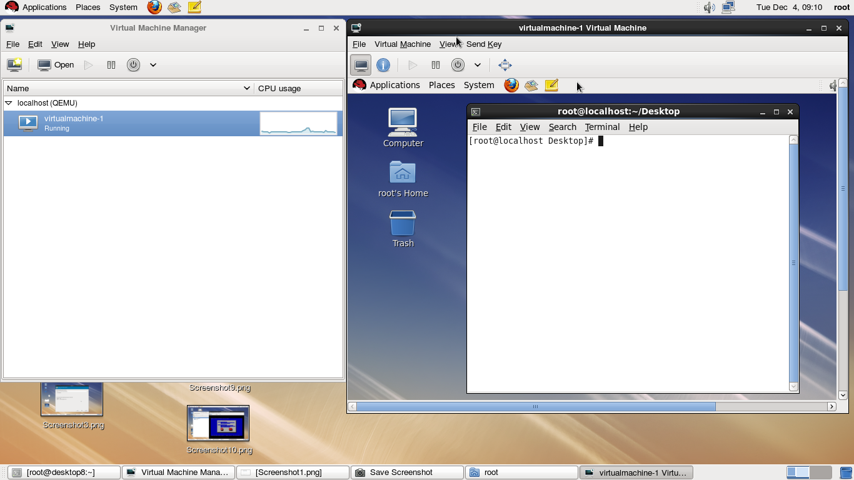

**DNS**

**[root@desktop50 ~]# hostname**

desktop50.example.com

**[root@desktop50 ~]# ifconfig eth0**

eth0 Link encap:Ethernet HWaddr 38:60:77:56:81:90

inet addr:192.168.0.50 Bcast:192.168.0.255 Mask:255.255.255.0

inet6 addr: fe80::3a60:77ff:fe56:8190/64 Scope:Link

UP BROADCAST RUNNING MULTICAST MTU:1500 Metric:1

RX packets:698 errors:0 dropped:0 overruns:0 frame:0

TX packets:248 errors:0 dropped:0 overruns:0 carrier:0

collisions:0 txqueuelen:1000

RX bytes:110281 (107.6 KiB) TX bytes:38754 (37.8 KiB)

Interrupt:29 Base address:0xc000

**[root@desktop50 ~]# yum install bind* -y**

**[root@desktop50 ~]# cd /var/named/chroot/**

**[root@desktop50 chroot]# ls**

dev etc usr var

**[root@desktop50 chroot]# cd etc**

**[root@desktop50 etc]# ls**

localtime named pki

**cp /etc/named.rfc1912.zones named.conf**

**[root@desktop50 etc]#**

**[root@desktop50 etc]# ll**

total 16

-rw-r--r--. 1 root root 265 May 17 17:00 localtime

drwxr-x---. 2 root named 4096 May 26 2010 named

-rw-r-----. 1 root root 931 May 17 17:01 named.conf

drwxr-xr-x. 3 root root 4096 May 17 17:00 pki

**[root@desktop50 etc]#**

**chgrp named** named.conf

**[root@desktop50 etc]#**

**[root@desktop50 etc]# ll**

total 16

-rw-r--r--. 1 root root 265 May 17 17:00 localtime

drwxr-x---. 2 root named 4096 May 26 2010 named

-rw-r-----. 1 root named 931 May 17 17:01 named.conf

drwxr-xr-x. 3 root root 4096 May 17 17:00 pki

**[root@desktop50 etc]# vim /etc/named.conf**

copy line from 10 to 26 line number for sysntax.(press 17yy for copy lines)

:edit named.conf (press enter)

paste thease lines in line number -12 (press p for paste)

and edit this file---

options {

listen-on port 53 { 192.168.0.50; };

listen-on-v6 port 53 { ::1; };

directory "/var/named";

dump-file "/var/named/data/cache_dump.db";

statistics-file "/var/named/data/named_stats.txt";

memstatistics-file "/var/named/data/named_mem_stats.txt";

allow-query { any; };

allow-transfer { 192.168.0.100; };

recursion yes;

dnssec-enable yes;

dnssec-validation yes;

dnssec-lookaside auto;

/* Path to ISC DLV key */

bindkeys-file "/etc/named.iscdlv.key";

};

zone "localhost.localdomain" IN {

type master;

file "named.localhost";

allow-update { none; };

};

zone "example.com" IN {

type master;

file "forward.zone";

allow-update { none; };

};

zone "1.0.0.0.0.0.0.0.0.0.0.0.0.0.0.0.0.0.0.0.0.0.0.0.0.0.0.0.0.0.0.0.ip6.arpa" IN {

type master;

file "named.loopback";

allow-update { none; };

};

zone "0.168.192.in-addr.arpa" IN {

type master;

file "reverse.zone";

allow-update { none; };

};

zone "0.in-addr.arpa" IN {

type master;

file "named.empty";

allow-update { none; };

};

:wq

**[root@desktop50 etc]# cd ..**

**[root@desktop50 chroot]# ls**

dev etc usr var

**[root@desktop50 chroot]# cd var/named/**

**[root@desktop50 named]# ls**

**cp -p /var/named/named.localhost forward.zone**

**cp -p /var/named/named.loopback reverse.zone**

**[root@desktop50 named]#**

**[root@desktop50 named]# ll**

total 8

-rw-r-----. 1 root named 152 Jun 21 2007 forward.zone

-rw-r-----. 1 root named 168 Dec 15 2009 reverse.zone

**[root@desktop50 named]#**

**cp -p /var/named/named.* .**

**[root@desktop50 named]# ll**

total 24

-rw-r-----. 1 root named 152 Jun 21 2007 forward.zone

-rw-r-----. 1 root named 1892 Feb 18 2008 named.ca

-rw-r-----. 1 root named 152 Dec 15 2009 named.empty

-rw-r-----. 1 root named 152 Jun 21 2007 named.localhost

-rw-r-----. 1 root named 168 Dec 15 2009 named.loopback

-rw-r-----. 1 root named 168 Dec 15 2009 reverse.zone

**[root@desktop50 named]# vim forward.zone**

$TTL 1D

@ IN SOA desktop50.example.com. root.desktop50.example.com. (

0 ; serial

1D ; refresh

1H ; retry

1W ; expire

3H ) ; minimum

NS desktop50.example.com.

desktop50 A 192.168.0.50

desktop100 A 192.168.0.100

server1 CNAME desktop50

server2 CNAME desktop100

**:wq**

**[root@desktop50 named]# vim reverse.zone**

$TTL 1D

@ IN SOA desktop50.example.com. root.desktop50.example.com. (

0 ; serial

1D ; refresh

1H ; retry

1W ; expire

3H ) ; minimum

NS desktop50.example.com.

50 PTR desktop50.example.com.

100 PTR desktop100.example.com.

:wq

**[root@desktop50 named]# cd**

**[root@desktop50 ~]#**

**[root@desktop50 ~]# vim /etc/resolv.conf**

search example.com

nameserver 192.168.0.50

**:wq**

**[root@desktop50 ~]# service named restart**

Stopping named: [ OK ]

Starting named: [ OK ]

[root@desktop50 ~]chkconfig named on

**dig desktop50.example.com**

; <<>> DiG 9.7.0-P2-RedHat-9.7.0-5.P2.el6 <<>> desktop50.example.com

;; global options: +cmd

;; Got answer:

;; ->>HEADER<<- opcode: QUERY, status: NOERROR, id: 61650

;; flags: qr aa rd ra; QUERY: 1, ANSWER: 1, AUTHORITY: 1, ADDITIONAL: 0

;; QUESTION SECTION:

;desktop50.example.com. IN A

;; ANSWER SECTION:

desktop50.example.com. 86400 IN A 192.168.0.50

;; AUTHORITY SECTION:

example.com. 86400 IN NS desktop50.example.com.

;; Query time: 0 msec

;; SERVER: 192.168.0.50#53(192.168.0.50)

;; WHEN: Fri May 17 17:30:29 2013

;; MSG SIZE rcvd: 69

**[root@desktop50 ~]# dig -x 192.168.0.50**

; <<>> DiG 9.7.0-P2-RedHat-9.7.0-5.P2.el6 <<>> -x 192.168.0.50

;; global options: +cmd

;; Got answer:

;; ->>HEADER<<- opcode: QUERY, status: NOERROR, id: 20555

;; flags: qr aa rd ra; QUERY: 1, ANSWER: 1, AUTHORITY: 1, ADDITIONAL: 1

;; QUESTION SECTION:

;50.0.168.192.in-addr.arpa. IN PTR

;; ANSWER SECTION:

50.0.168.192.in-addr.arpa. 86400 IN PTR desktop50.example.com.

;; AUTHORITY SECTION:

0.168.192.in-addr.arpa. 86400 IN NS desktop50.example.com.

;; ADDITIONAL SECTION:

desktop50.example.com. 86400 IN A 192.168.0.50

;; Query time: 0 msec

;; SERVER: 192.168.0.50#53(192.168.0.50)

;; WHEN: Fri May 17 17:31:18 2013

;; MSG SIZE rcvd: 108

**[root@desktop50 ~]# host 192.168.0.50**

50.0.168.192.in-addr.arpa domain name pointer desktop50.example.com.

**[root@desktop50~]#hostdesktop50.exampleom**

desktop50.example.com has address 192.168.0.50

**nslookupdesktop50.example.com**

Server: 192.168.0.50

Address: 192.168.0.50#53

Name: desktop50.example.com

Address: 192.168.0.50

**[root@desktop50 ~]# nslookup 192.168.0.50**

Server: 192.168.0.50

Address: 192.168.0.50#53

50.0.168.192.in-addr.arpa name = desktop50.example.com.

##############DNS Master server finished #############

**[root@desktop100 ~]# hostname desktop100.example.com**

**[root@desktop100 ~]# vim /etc/sysconfig/network**

NETWORKING=yes

HOSTNAME=desktop100.example.com

**:wq**

**[root@desktop100 ~]# ifconfig eth0**

eth0 Link encap:Ethernet HWaddr 38:60:77:7B:A4:04

inet addr:192.168.0.100 Bcast:192.168.0.255 Mask:255.255.255.0

inet6 addr: fe80::3a60:77ff:fe7b:a404/64 Scope:Link

UP BROADCAST RUNNING MULTICAST MTU:1500 Metric:1

RX packets:6865 errors:0 dropped:0 overruns:0 frame:0

TX packets:6023 errors:0 dropped:0 overruns:0 carrier:0

collisions:0 txqueuelen:1000

RX bytes:1216815 (1.1 MiB) TX bytes:567772 (554.4 KiB)

Interrupt:29 Base address:0xe000

**[root@desktop100 ~]# yum install bind* -y**

**[root@desktop100 ~]# cd**

/var/named/chroot/

**[root@desktop100 chroot]# ls**

dev etc usr var

**[root@desktop100 chroot]#**

**[root@desktop100 chroot]# cd etc**

**[root@desktop100 etc]#**

**[root@desktop100 etc]# ls**

localtime named pki

**[root@desktop100 etc]#**

**[root@desktop100 etc]# cp –p**

/etc/named.rfc1912.zones named.conf

**[root@desktop100 etc]#**

**[root@desktop100 etc]# ll**

total 16

-rw-r--r--. 1 root root 265 May 17 17:36 localtime

drwxr-x---. 2 root named 4096 May 26 2010 named

-rw-r-----. 1 root named 931 Jun 21 2007 named.conf

drwxr-xr-x. 3 root root 4096 May 17 17:36 pki

perform same step like master server.

copy line from 10 to 26 line number for sysntax.(press 17yy for copy lines)

:edit named.conf (press enter)

paste thease lines in line number -12 (press p for paste)

and edit this file---

options {

listen-on port 53 { 192.168.0.100; };

listen-on-v6 port 53 { ::1; };

directory "/var/named";

dump-file "/var/named/data/cache_dump.db";

statistics-file "/var/named/data/named_stats.txt";

memstatistics-file "/var/named/data/named_mem_stats.txt";

allow-query { any; };

allow-transfer { none; };

recursion yes;

dnssec-enable yes;

dnssec-validation yes;

dnssec-lookaside auto;

/* Path to ISC DLV key */

bindkeys-file "/etc/named.iscdlv.key";

};

zone "localhost.localdomain" IN {

type master;

file "named.localhost";

allow-update { none; };

};

zone "example.com" IN {

type slave;

masters { 192.168.0.50; };

file "slaves/forward.zone";

allow-update { none; };

};

zone "1.0.0.0.0.0.0.0.0.0.0.0.0.0.0.0.0.0.0.0.0.0.0.0.0.0.0.0.0.0.0.0.ip6.arpa" IN {

type master;

file "named.loopback";

allow-update { none; };

};

zone "0.168.192.in-addr.arpa" IN {

type slave;

masters { 192.168.0.50; };

file "slaves/reverse.zone";

allow-update { none; };

};

zone "0.in-addr.arpa" IN {

type master;

file "named.empty";

allow-update { none; };

};

**:wq**

**[root@desktop100 etc]# cd**

**[root@desktop100 ~]#**

**[root@desktop100 ~]# vim /etc/resolv.conf**

search example.com

nameserver 192.168.0.50

nameserver 192.168.0.100

**:wq**

**service named restart**

Stopping named: [ OK ]

Starting named: [ OK ]

**[root@desktop100 ~]# chkconfig named on**

**dig desktop50.example.com**

; <<>> DiG 9.7.0-P2-RedHat-9.7.0-5.P2.el6 <<>> desktop50.example.com

;; global options: +cmd

;; Got answer:

;; ->>HEADER<<- opcode: QUERY, status: NOERROR, id: 2865

;; flags: qr aa rd ra; QUERY: 1, ANSWER: 1, AUTHORITY: 1, ADDITIONAL: 0

;; QUESTION SECTION:

;desktop50.example.com. IN A

;; ANSWER SECTION:

desktop50.example.com. 86400 IN A 192.168.0.50

;; AUTHORITY SECTION:

example.com. 86400 IN NS desktop50.example.com.

;; Query time: 0 msec

;; SERVER: 192.168.0.50#53(192.168.0.50)

;; WHEN: Fri May 17 17:44:56 2013

;; MSG SIZE rcvd: 69

**dig desktop100.example.com**

; <<>> DiG 9.7.0-P2-RedHat-9.7.0-5.P2.el6 <<>> desktop100.example.com

;; global options: +cmd

;; Got answer:

;; ->>HEADER<<- opcode: QUERY, status: NOERROR, id: 11119

;; flags: qr aa rd ra; QUERY: 1, ANSWER: 1, AUTHORITY: 1, ADDITIONAL: 1

;; QUESTION SECTION:

;desktop100.example.com. IN A

;; ANSWER SECTION:

desktop100.example.com. 86400 IN A 192.168.0.100

;; AUTHORITY SECTION:

example.com. 86400 IN NS desktop50.example.com.

;; ADDITIONAL SECTION:

desktop50.example.com. 86400 IN A 192.168.0.50

;; Query time: 0 msec

;; SERVER: 192.168.0.50#53(192.168.0.50)

;; WHEN: Fri May 17 17:45:27 2013

;; MSG SIZE rcvd: 96

**[root@desktop100 ~]# dig -x 192.168.0.50**

; <<>> DiG 9.7.0-P2-RedHat-9.7.0-5.P2.el6 <<>> -x 192.168.0.50

;; global options: +cmd

;; Got answer:

;; ->>HEADER<<- opcode: QUERY, status: NOERROR, id: 45127

;; flags: qr aa rd ra; QUERY: 1, ANSWER: 1, AUTHORITY: 1, ADDITIONAL: 1

;; QUESTION SECTION:

;50.0.168.192.in-addr.arpa. IN PTR

;; ANSWER SECTION:

50.0.168.192.in-addr.arpa. 86400 IN PTR desktop50.example.com.

;; AUTHORITY SECTION:

0.168.192.in-addr.arpa. 86400 IN NS desktop50.example.com.

;; ADDITIONAL SECTION:

desktop50.example.com. 86400 IN A 192.168.0.50

;; Query time: 0 msec

;; SERVER: 192.168.0.50#53(192.168.0.50)

;; WHEN: Fri May 17 17:45:51 2013

;; MSG SIZE rcvd: 108

**[root@desktop100 ~]# dig -x 192.168.0.100**

; <<>> DiG 9.7.0-P2-RedHat-9.7.0-5.P2.el6 <<>> -x 192.168.0.100

;; global options: +cmd

;; Got answer:

;; ->>HEADER<<- opcode: QUERY, status: NOERROR, id: 49414

;; flags: qr aa rd ra; QUERY: 1, ANSWER: 1, AUTHORITY: 1, ADDITIONAL: 1

;; QUESTION SECTION:

;100.0.168.192.in-addr.arpa. IN PTR

;; ANSWER SECTION:

100.0.168.192.in-addr.arpa. 86400 IN PTR desktop100.example.com.

;; AUTHORITY SECTION:

0.168.192.in-addr.arpa. 86400 IN NS desktop50.example.com.

;; ADDITIONAL SECTION:

desktop50.example.com. 86400 IN A 192.168.0.50

;; Query time: 0 msec

;; SERVER: 192.168.0.50#53(192.168.0.50)

;; WHEN: Fri May 17 17:46:24 2013

;; MSG SIZE rcvd: 120

cd /var/named/chroot/var/named/

[root@desktop100 named]# ls

chroot data dynamic named.ca named.empty named.localhost named.loopback slaves

**[root@desktop100 named]# cd slaves/**

**[root@desktop100 slaves]# ls**

forward.zone reverse.zone

[root@desktop100 slaves]# cat forward.zone

$ORIGIN .

$TTL 86400 ; 1 day

example.com IN SOA desktop50.example.com. root.desktop50.example.com. (

0 ; serial

86400 ; refresh (1 day)

3600 ; retry (1 hour)

604800 ; expire (1 week)

10800 ; minimum (3 hours)

)

NS desktop50.example.com.

$ORIGIN example.com.

desktop100 A 192.168.0.100

desktop50 A 192.168.0.50

server1 CNAME desktop50

server2 CNAME desktop100

**reverse.zone**

$ORIGIN .

$TTL 86400 ; 1 day

0.168.192.in-addr.arpa IN SOA desktop50.example.com. root.desktop50.example.com. (

0 ; serial

86400 ; refresh (1 day)

3600 ; retry (1 hour)

604800 ; expire (1 week)

10800 ; minimum (3 hours)

)

NS desktop50.example.com.

$ORIGIN 0.168.192.in-addr.arpa.

100 PTR desktop100.example.com.

50 PTR desktop50.example.com.

**[root@desktop100 slaves]# cd**

**[root@desktop100 ~]#**

################# DNS Slave Server finished#####################

**Telnet Server**

**[root@desktop100 ~]# yum install telnet* -y**

**[root@desktop100 ~]# vim /etc/xinetd.d/telnet**

disable = yes

(note- edit right side option- yes to no)

disable = no

**:wq**

**[root@desktop100 ~]# service xinetd restart**

Stopping xinetd: [ OK ]

Starting xinetd:

[ OK ]

**[root@desktop100 ~]# chkconfig xinetd on**

**[root@desktop100 ~]#**

**netstat -tunlp | grep xinetd**

tcp 0 0 :::23 :::* LISTEN 28039/xinetd

**[root@desktop100 ~]#**

**[root@desktop100 ~]# useradd krishna**

**[root@desktop100 ~]#**

**[root@desktop100 ~]# passwd Krishna**

Changing password for user krishna.

New password:

BAD PASSWORD: it is WAY too short

BAD PASSWORD: is too simple

Retype new password:

passwd: all authentication tokens updated successfully.

now from client machine----

Trying 192.168.0.100...

Connected to 192.168.0.100.

Escape character is '^]'.

Red Hat Enterprise Linux Server release 6.0 (Santiago)

Kernel 2.6.32-71.el6.x86_64 on an x86_64

login: krishna

Password:

[krishna@desktop100 ~]$

[krishna@desktop100 ~]$ pwd

/home/krishna

[krishna@desktop100 ~]$ mkdir data

[krishna@desktop100 ~]$ ls

data

[krishna@desktop100 ~]$ touch abc

[krishna@desktop100 ~]$ ls

abc data

[krishna@desktop100 ~]$

do't log out from this accont..

go in again server side just for monitoring.

server side----------

**[root@desktop100 ~]# who**

root tty1 2013-05-17 16:52 (:0)

root pts/0 2013-05-17 17:51 (:0.0)

root pts/1 2013-05-17 18:18 (:0.0)

krishna pts/2 2013-05-17 18:18 (desktop50)

**[root@desktop100 ~]# w**

18:20:22 up 1:29, 4 users, load average: 0.00, 0.00, 0.00

USER TTY FROM LOGIN@ IDLE JCPU PCPU WHAT

root tty1 :0 16:52 1:29m 48.30s 48.30s /usr/bin/Xorg

root pts/0 :0.0 17:51 0.00s 0.16s 0.05s w

krishna pts/2 desktop50 18:18 1:17 0.01s 0.01s -bash

**[root@desktop100 ~]# pinky**

Login Name TTY Idle When Where

root root tty1 01:30 2013-05-17 16:52 :0

root root pts/0 2013-05-17 17:51 :0.0

root root pts/1 00:02 2013-05-17 18:18 :0.0

krishna pts/2 00:02 2013-05-17 18:18 desktop50.example.com

**[root@desktop100 ~]# cd /home/krishna/**

**[root@desktop100 krishna]# ls**

abc data

[root@desktop100 krishna]# ll

total 4

-rw-rw-r--. 1 krishna krishna 0 May 17 18:19 abc

drwxrwxr-x. 2 krishna krishna 4096 May 17 18:19 data

**[root@desktop100 krishna]# cd**

**[root@desktop100 ~]# tail -f /var/log/secure**

May 17 17:36:11 desktop16 groupadd[27193]: group added to /etc/group: name=named, GID=25

May 17 17:36:11 desktop16 groupadd[27193]: group added to /etc/gshadow: name=named

May 17 17:36:11 desktop16 groupadd[27193]: new group: name=named, GID=25

May 17 17:36:11 desktop16 useradd[27198]: new user: name=named, UID=25, GID=25, home=/var/named, shell=/sbin/nologin

May 17 18:17:03 desktop16 useradd[28044]: new group: name=krishna, GID=500

May 17 18:17:03 desktop16 useradd[28044]: new user: name=krishna, UID=500, GID=500, home=/home/krishna, shell=/bin/bash

May 17 18:17:10 desktop16 passwd: pam_unix(passwd:chauthtok): password changed for krishna

May 17 18:17:10 desktop16 passwd: gkr-pam: couldn't update the 'login' keyring password: no old password was entered

May 17 18:18:52 desktop16 login: pam_unix(remote:session): session opened for user krishna by (uid=0)

May 17 18:18:52 desktop16 login: LOGIN ON pts/2 BY krishna FROM desktop50

**Press CTRL+C to exit**

Note- (By default root superuser is not allow for telnet login due to PAM policy )

now- how to allow telnet service for root superuser.

**[root@desktop100 ~]# vim /etc/pam.d/remote**

#%PAM-1.0

auth required pam_securetty.so

note- comment line number two.

#%PAM-1.0

#auth required pam_securetty.so

:wq

**[root@desktop100 ~]# service xinetd restart**

**[root@desktop100 ~]#**

**[root@desktop100 ~]# chkconfig xinetd on**

Now again on client machine-----

**[root@desktop50 ~]# telnet 192.168.0.100**

Trying 192.168.0.100...

Connected to 192.168.0.100.

Escape character is '^]'.

Red Hat Enterprise Linux Server release 6.0 (Santiago)

Kernel 2.6.32-71.el6.x86_64 on an x86_64

login: root

Password:

**[root@desktop100 ~]# pwd**

**/root**

**[root@desktop100 ~]# exit**

logout

Connection closed by foreign host.

now again on server side-- apply security

**[root@desktop100 ~]# vim /etc/xinetd.d/telnet**

service telnet

{

flags = REUSE

socket_type = stream

wait = no

user = root

server = /usr/sbin/in.telnetd

log_on_failure += USERID

disable = no

only_from = 192.168.0.0/24

no_access = 192.168.0.50

log_on_success += HOST DURATION PID USERID

log_type = FILE /var/log/networkcloud

}

**:wq**

**[root@desktop100 ~]# service xinetd restart**

**[root@desktop100 ~]# chkconfig xinetd on**

again on client side machine- for testing---

**[root@desktop50 ~]# telnet 192.168.0.100**

Trying 192.168.0.100...

Connected to 192.168.0.100.

Escape character is '^]'.

Connection closed by foreign host.

######################## telnet finish #########################

$$$$$$$$$$$$$$$$$ LVM $$$$$$$$$$$$$$$$$$$$$$$$

**[root@desktop6 ~]#rpm -qa lvm\***

lvm2-2.02.72-8.el6.x86_64

lvm2-libs-2.02.72-8.el6.x86_64

**[root@desktop6 ~]# fdisk -c /dev/sda**

The device presents a logical sector size that is smaller than

the physical sector size. Aligning to a physical sector (or optimal

I/O) size boundary is recommended, or performance may be impacted.

WARNING: cylinders as display units are deprecated. Use coommand (m for help): n

First cylinder (3648-30401, default 3648):

Using default value 3648

Last cylinder, +cylinders or +size{K,M,G} (3648-30401, default 30401): +2G ommand (m for help): n

First cylinder (3648-30401, default 3648):

Using default value 3648

Last cylinder, +cylinders or +size{K,M,G} (3648-30401, default 30401): +2G mmand 'u' to

change units to sectors.

.

Command (m for help): p

Disk /dev/sda: 250.1 GB, 250059350016 bytes

255 heads, 63 sectors/track, 30401 cylinders

Units = cylinders of 16065 * 512 = 8225280 bytes

Sector size (logical/physical): 512 bytes / 4096 bytes

I/O size (minimum/optimal): 4096 bytes / 4096 bytes

Disk identifier: 0x00040a44

Device Boot Start End Blocks Id System

/dev/sda1 * 1 13 102400 83 Linux

/dev/sda2 13 3583 28672000 8e Linux LVM

/dev/sda3 3583 3648 524288 82 Linux swap / Solaris

Command (m for help): n

Command action

e extended

p primary partition (1-4)

e

Selected partition 4

First cylinder (3648-30401, default 3648): blenck enter

Using default value 3648

Last cylinder, +cylinders or +size{K,M[root@desktop6 ~]#,G} (3648-30401, default 30401): blenck Enter

Command (m for help): n

First cylinder (3648-30401, default 3648):

Using default value 3648

Last cylinder, +cylinders or +size{K,M,G} (3648-30401, default 30401): +2G

Command (m for help): p

Disk /dev/sda: 250.1 GB, 250059350016 bytes

255 heads, 63 sectors/track, 30401inders

Units = cylinders of 16065 * 512 = 8225280 bytes

Sector size (logical/physical): 512 bytes / 4096 bytes

I/O size (minimum/optimal): 4096 bytes / 4096 bytes

Disk identifier: 0x00040a44

Device Boot Start End Blocks Id System

/dev/sda1 * 1 13 102400 83 Linux

/dev/sda2 13 3583 28672000 8e Linux LVM

/dev/sda3 3583 3648 524288 82 Linux swap / Solaris

/dev/sda4 3648 30401 214896320+ 5 Extended

/dev/sda5 3648 3909 2098176 83 Linux

Command (m for help): t for the code change

Partition number (1-5): 5

Hex code (type L to list codes): 8e this is LVM code

Changed system type of partition 5 to 8e (Linux LVM)

Command (m for help) : p

Disk /dev/sda: 250.1 GB, 250059350016 bytes

255 heads, 63 sectors/track, 30401 cylinders

Units = cylinders of 16065 * 512 = 8225280 bytes

Sector size (logical/physical): 512 bytes / 4096 bytes

I/O size (minimum/optimal): 4096 bytes / 4096 bytes

Disk identifier: 0x00040a44

Device Boot Start End Blocks Id System

/dev/sda1 * 1 13 102400 83 Linux

/dev/sda2 13 3583 28672000 8e Linux LVM

/dev/sda3 3583 3648 524288 82 Linux swap / Solaris

/dev/sda4 3648 30401 214896320+ 5 Extended

/dev/sda5 3648 3909 2098176 8e Linux LVM

Command (m for help):w

The partition table has been altered!

Calling ioctl() to re-read partition table.

WARNING: Re-reading the partition table failed with error 16: Device or resource busy.

The kernel still uses the old table. The new table will be used at

the next reboot or after you run partprobe(8) or kpartx(8)

Syncing disks.

**[root@desktop6 ~]# partx -a /dev/sda**

BLKPG: Device or resource busy

error adding partition 1

BLKPG: Device or resource busy

error adding partition 2

BLKPG: Device or resource busy

error adding partition 3

**[root@desktop6 ~]# partx -a /dev/sda**

BLKPG: Device or resource busy

error adding partition 1

BLKPG: Device or resource busy

error adding partition 2

BLKPG: Device or resource busy

error adding partition 3

BLKPG: Device or resource busy

error adding partition 4

BLKPG: Device or resource busy

error adding partition 5

**[root@desktop6 ~]# pvcreate /dev/sda5**

**Physical volume "/dev/sda5"**

successfully created

**[root@desktop6 ~]# pvdisplay**

--- Physical volume ---

PV Name /dev/sda2

VG Name vol0

PV Size 27.34 GiB / not usable 32.00 MiB

Allocatable yes

PE Size 32.00 MiB

Total PE 874

Free PE 602

Allocated PE 272

PV UUID XQ38KG-sHvC-S3nV-gwFl-pZuU-S1li-qdfdBx

"/dev/sda5" is a new physical volume of "2.00 GiB"

--- NEW Physical volume ---

PV Name /dev/sda5

VG Name

PV Size 2.00 GiB

Allocatable NO

PE Size 0

Total PE 0

Free PE 0

Allocated PE 0

PV UUID e8rdSx-l589-M50k-hue8-Qqtx-3LQS-7tkryN

**[root@desktop6 ~]# vgcreate vg0 /dev/sda5**

Volume group "vg0" successfully created

**[root@desktop6 ~]# vgdisplay**

--- Volume group ---

VG Name vg0

System ID

Format lvm2

Metadata Areas 1

Metadata Sequence No 1

VG Access read/write

VG Status resizable

MAX LV 0

Cur LV 0

Open LV 0

Max PV 0

Cur PV 1

Act PV 1

VG Size 2.00 GiB

PE Size 4.00 MiB

Total PE 512

Alloc PE / Size 0 / 0

Free PE / Size 512 / 2.00 GiB

VG UUID lYNNui-sLnW-bMPd-txF5-sEQQ-l2jB-IVb3og

--- Volume group ---

VG Name vol0

System ID

Format lvm2

Metadata Areas 1

Metadata Sequence No 3

VG Access read/write

VG Status resizable

MAX LV 0

Cur LV 2

Open LV 2

Max PV 0

Cur PV 1

Act PV 1

VG Size 27.31 GiB

PE Size 32.00 MiB

Total PE 874

Alloc PE / Size 272 / 8.50 GiB

Free PE / Size 602 / 18.81 GiB

VG UUID uZ5e0c-y3Cq-F5YQ-vQg4-8HsE-GphH-RcZnXD

**[root@desktop6 ~]# vgs for size[root@desktop6 ~]#** resize2fs /dev/vg0/lv0

resize2fs 1.41.12 (17-May-2010)

Filesystem at /dev/vg0/lv0 is mounted on /lvm; on-line resizing required

old desc_blocks = 1, new_desc_blocks = 1

Performing an on-line resize of /dev/vg0/lv0 to 128000 (4k) blocks.

The filesystem on /dev/vg0/lv0 is now 128000 blocks long.

VG #PV #LV #SN Attr VSize VFree

vg0 1 0 0 wz--n- 2.00g 2.00g

vol0 1 2 0 wz--n- 27.31g 18.81g

**[root@desktop6 ~]# lvcreate -L +300 -n lv0 /dev/vg0**

**Logical volume "lv0" created**

**[root@desktop6 ~]# lvdisplay**

--- Logical volume ---

LV Name /dev/vg0/lv0

VG Name vg0

LV UUID tKq9ic-yXRT-Cy2X-0d8t-P2u7-w4Zb-vWmtrf

LV Write Access read/write

LV Status available

# open 0[root@desktop6 ~]# resize2fs /dev/vg0/lv0

resize2fs 1.41.12 (17-May-2010)

Filesystem at /dev/vg0/lv0 is mounted on /lvm; on-line resizing required

old desc_blocks = 1, new_desc_blocks = 1

Performing an on-line resize of /dev/vg0/lv0 to 128000 (4k) blocks.

The filesystem on /dev/vg0/lv0 is now 128000 blocks long.

LV Size 300.00 MiB

Current LE 75

Segments 1

Allocation inherit

Read ahead sectors auto

- currently set to 256

Block device 253:2

--- Logical volume ---

LV Name /dev/vol0/root

VG Name vol0

LV UUID PrOeTO-DXq2-ccdW-oxTW-TLxe-YTJb-BpGL9J

LV Write Access read/write

LV Status available

# open 1

LV Size 8.00 GiB

Current LE 256

Segments 1

Allocation inherit

Read ahead sectors auto

- currently set to 256

Block device 253:0

--- Logical volume ---

LV Name /dev/vol0/home

VG Name vol0

LV UUID J4mPr7-eQ2T-6J1z-Awbi-qdnE-s0MG-nmma8z

LV Write Access read/write[root@desktop6 ~]# resize2fs /dev/vg0/lv0

resize2fs 1.41.12 (17-May-2010)

Filesystem at /dev/vg0/lv0 is mounted on /lvm; on-line resizing required

old desc_blocks = 1, new_desc_blocks = 1

Performing an on-line resize of /dev/vg0/lv0 to 128000 (4k) blocks.

The filesystem on /dev/vg0/lv0 is now 128000 blocks long.

LV Status available

# open 1

LV Size 512.00 MiB

Current LE 16

Segments 1

Allocation inherit

Read ahead sectors auto

- currently set to 256

Block device 253:1

**[root@desktop6 ~]# lvs**

LV VG Attr LSize Origin Snap% Move Log Copy% Convert

lv0 vg0 -wi-a- 300.00m

home vol0 -wi-ao 512.00m

root vol0 -wi-ao 8.00g

**[root@desktop6 ~]# mkfs.ext4 /dev/vg0/lv0**

mke2fs 1.41.12 (17-May-2010)

Filesystem label=

OS type: Linux

Block size=4096 (log=2)

Fragment size=4096 (log=2)

Stride=1 blocks, Stripe width=0 blocks

76800 inodes, 76800 blocks

3840 blocks (5.00%) reserved for the super user

First data block=0

Maximum filesystem blocks=79691776

3 block groups

32768 blocks per group, 32768 fragments per group

25600 inodes per group

Superblock backups stored on blocks:

32768

Writing inode tables: done

Creating journal (4096 blocks): done

Writing superblocks and filesystem accounting information: done

This filesystem will be automatically checked every 35 mounts or

180 days, whichever comes first. Use tune2fs -c or -i to override.

**[root@desktop6 ~]# mkdir /lvm**

**[root@desktop6 ~]# mount /dev/vg0/lv0 /lvm**

**[root@desktop6 ~]# vim /etc/fstab**

/dev/mapper/vol0-root / ext4 defaults 1 1

UUID=189f10bb-0821-4fcc-8981-a0fa18dbf935 /boot ext4 defaults 1 2

/dev/mapper/vol0-home /home ext4 defaults 1 2

UUID=6783591f-75bd-4c5f-ba75-ff98e791eabb swap swap defaults 0 0

tmpfs /dev/shm tmpfs defaults 0 0

devpts /dev/pts devpts gid=5,mode=620 0 0

sysfs /sys sysfs defaults 0 0

proc /proc proc defaults 0 0

/dev/vg0/lv0 /lvm ext4 defaults 0 0

**:wq!**

**[root@desktop6 ~]# cd /lvm/**

**[root@desktop6 lvm]# ls**

lost+found

**[root@desktop6 lvm]# mkdir hcl**

**[root@desktop6 lvm]# ls**

hcl lost+found

**[root@desktop6 lvm]# ls**

**[root@desktop6 lvm]# cd**

**[root@desktop6 ~]#**

Lvm partition sucessfully creted done

_____________________________________

How to extent Lvm

________________

**[root@desktop6 ~]# lvextend -L +200M /dev/vg0/lv0**

Extending logical volume lv0 to 500.00 MiB

Logical volume lv0 successfully resized

**[root@desktop6 ~]# resize2fs /dev/vg0/lv0**

resize2fs 1.41.12 (17-May-2010)

Filesystem at /dev/vg0/lv0 is mounted on /lvm; on-line resizing required

old desc_blocks = 1, new_desc_blocks = 1

Performing an on-line resize of /dev/vg0/lv0 to 128000 (4k) blocks.

The filesystem on /dev/vg0/lv0 is now 128000 blocks long.

**[root@desktop6 ~]#**

How to lvm reduce

________________

**[root@desktop6 ~]# unmount /lvm**

**[root@desktop6 ~]# e2fsck -f /dev/vg0/lv0**

e2fsck 1.41.12 (17-May-2010)

Pass 1: Checking inodes, blocks, and sizes

Pass 2: Checking directory structure

Pass 3: Checking directory connectivity

Pass 4: Checking reference counts

Pass 5: Checking group summary information

/dev/vg0/lv0: 12/102400 files (0.0% non-contiguous), 7372/128000 blocks

**[root@desktop6 ~]# resize2fs /dev/vg0/lv0 200m**

resize2fs 1.41.12 (17-May-2010)

Resizing the filesystem on /dev/vg0/lv0 to 51200 (4k) blocks.

The filesystem on /dev/vg0/lv0 is now 51200 blocks long.

**[root@desktop6 ~]# lvreduce -L -200M /dev/vg0/lv0**

WARNING: Reducing active logical volume to 300.00 MiB

THIS MAY DESTROY YOUR DATA (filesystem etc.)

Do you really want to reduce lv0? [y/n]: y

Reducing logical volume lv0 to 300.00 MiB

Logical volume lv0 successfully resized

**[root@desktop6 ~]# e2fsck -f /dev/vg0/lv0**

e2fsck 1.41.12 (17-May-2010)

Pass 1: Checking inodes, blocks, and sizes

Pass 2: Checking directory structure

Pass 3: Checking directory connectivity

Pass 4: Checking reference counts

Pass 5: Checking group summary information

/dev/vg0/lv0: 12/51200 files (0.0% non-contiguous), 5748/51200 blocks

**[root@desktop6 ~]# mount /lvm/**

**[root@desktop6 ~]# lvdisplay**

--- Logical volume ---

LV Name /dev/vg0/lv0

VG Name vg0

LV UUID tKq9ic-yXRT-Cy2X-0d8t-P2u7-w4Zb-vWmtrf

LV Write Access read/write

LV Status available

# open 1

LV Size 300.00 MiB

Current LE 75

Segments 1

Allocation inherit

Read ahead sectors auto

- currently set to 256

Block device 253:2

How to remove L

_________________

**[root@desktop6 ~]# umount /lvm**

**[root@desktop6 ~]# vim /etc/fstab (**

**delete the** entry forlvm)

**[root@desktop6 ~]# lvremove /dev/vg0/lv0**

**[root@desktop6 ~]# vgremove /dev/vg0**

**[root@desktop6 ~]# pvremove /dev/sda5**

Done

$$$$$$$$$$$$$$ DHCP $$$$$$$$$$$$$$$

**[root@desktop5 ~]# setup {to configure system ip manually}**

**[root@desktop5 ~]# service network restart**

**[root@desktop5 ~]# chkconfig network on**

**[root@desktop5 ~]# ifconfig eth0**

eth0 Link encap:Ethernet HWaddr 38:60:77:7B:A3:D7

inet addr:192.168.0.5 Bcast:192.168.0.255 Mask:255.255.255.0

inet6 addr: fe80::3a60:77ff:fe7b:a3d7/64 Scope:Link

UP BROADCAST RUNNING MULTICAST MTU:1500 Metric:1

RX packets:2206 errors:0 dropped:0 overruns:0 frame:0

TX packets:933 errors:0 dropped:0 overruns:0 carrier:0

collisions:0 txqueuelen:1000

RX bytes:419531 (409.6 KiB) TX bytes:73273 (71.5 KiB)

Interrupt:29 Base address:0xe000

**[root@desktop5 ~]# yum install dhcp* -y**

**[root@desktop5 ~]# vim /etc/dhcp/dhcpd.conf**

# DHCP Server Configuration file.

# see /usr/share/doc/dhcp*/dhcpd.conf.sample

# see 'man 5 dhcpd.conf'

note- ( read carefully from here only location of sample file,to copy syntax of dhcp )

:q! (for quit without save)

**[root@desktop5 ~]# vim /usr/share/doc/dhcp-**

4.1.1/dhcpd.conf.sample

subnet 10.5.5.0 netmask 255.255.255.224 {

range 10.5.5.26 10.5.5.30;

option domain-name-servers ns1.internal.example.org;

option domain-name "internal.example.org";

option routers 10.5.5.1;

option broadcast-address 10.5.5.31;

default-lease-time 600;

max-lease-time 7200;

}

(Note- copy these lines from line number-47 to 55 line number. by using press- 9yy)

:edit /etc/dhcp/dhcpd.conf (press enter)

end paste on line number- 5

press p to paste

subnet 192.168.0.0 netmask 255.255.255.0 {

range 192.168.0.1 192.168.0.254;

option domain-name-servers 192.168.0.5;

option domain-name "example.com";

option ntp-servers 192.168.0.5;

option routers 192.168.0.5;

default-lease-time 600;

max-lease-time 7200;

}

**:wq**

(Note - Edit this file )

**[root@desktop5 ~]# service dhcpd restart**

**[root@desktop5 ~]# chkconfig dhcpd on**

**[root@desktop5 ~]# netstat -tunlp | grep dhcpd**

**now in client side ---------------**

first method to configure dhcp client.

#dhclient

or

second method by using setup command.

#setup

take ip by using dhcp and save and quit

**[root@desktop5 ~]# service network restart**

**[root@desktop5 ~]# chkconfig network on**

**[root@desktop5 ~]# ifconfig eth0**

eth0 Link encap:Ethernet HWaddr 38:60:77:7B:A3:D7

inet addr:192.168.0.1 Bcast:192.168.0.255 Mask:255.255.255.0

inet6 addr: fe80::3a60:77ff:fe7b:a3d7/64 Scope:Link

UP BROADCAST RUNNING MULTICAST MTU:1500 Metric:1

RX packets:2206 errors:0 dropped:0 overruns:0 frame:0

TX packets:933 errors:0 dropped:0 overruns:0 carrier:0

collisions:0 txqueuelen:1000

RX bytes:419531 (409.6 KiB) TX bytes:73273 (71.5 KiB)

Interrupt:29 Base address:0xe000

**Now again in Server side-----------**

**tail -f /var/log/messages {to read log}**

**vim /var/lib/dhcpd/dhcpd.leases{to read acknowledgement file}**

lease 192.168.0.1 {

starts 2 2013/05/21 12:39:02;

ends 2 2013/05/21 12:49:02;

tstp 2 2013/05/21 12:49:02;

cltt 2 2013/05/21 12:39:02;

binding state free;

hardware ethernet 38:60:77:7b:a3:d7;

}

**:Wq!**

############### now DHCP reservation ##############

for systax help copy 4 lines from dhcp sample file.

**[root@desktop5 ~]# vim /usr/share/doc/dhcp-4.1.1/dhcpd.conf.sample**

(Note- copy these lines from line number- 75 to 78 line number. by using press- 4yy)

host fantasia {

hardware ethernet 08:00:07:26:c0:a5;

fixed-address fantasia.fugue.com;

}

:edit /etc/dhcp/dhcpd.conf

press p to paste in bottom of the file.

host desktop100 {

hardware ethernet 38:60:77:56:80:e4; ( note - copy this mac address from dhcd lease file )

fixed-address 192.168.0.100;

}

**:wq!**

**[root@desktop5 ~]# service dhcpd restart**

**[root@desktop5 ~]# chkconfig dhcpd on**

again go in client site

---

#ifdown eth0

#ifup eth0

**[root@desktop5 ~]# ifconfig eth0**

eth0 Link encap:Ethernet HWaddr 38:60:77:7B:A3:D7

inet addr:192.168.0.100 Bcast:192.168.0.255 Mask:255.255.255.0

this is ok friends

**-------------- PXE Boot & Kickstart Server _________________**

**step-1**

configure YUM server {already discussed in last chapter }

**step-2**

#yum install syslinux* xinetd* tftp-server* dhcp* httpd*y

#yum install system-config-kickstart* -y

save this file with name

filename ks.cfg

location /root

save and quit

**step-3**

configure TFTP server.

#vim /etc/xinetd.d/tftp

disble= no

**:wq**

#service xinetd restart

#chkconfig xinetd on

#servce httpd restart

#chkconfig httpd on

**step-4**

insert rhel dvd and copy all dvd files into /var/www/html/rhel6 directory.

#mkdir -p /var/www/html/rhel6 (to copy all dvd files)

#mkdir -p /var/www/html/ks (to save answer file)

#cp ks.cfg /var/www/html/ks/ks.cfg

#chmod 644 /var/www/html/ks/ks.cfg

**step-5**

configure DHCP server with script

#vi /etc/dhcp/dhcpd.conf

Allow booting;

Allow bootp;

authoritative;

subnet 192.168.0.0 netmask 255.255.255.0 {

option routers 192.168.0.1;

option subnet-mask 255.255.255.0;

option domain-name "example.com";

option domain-name-servers 192.168.0.1;

default-lease-time 21600;

max-lease-time 43200;

range dynamic-bootp 192.168.0.100 192.168.0.200;

filename "pxelinux.0";

next-server 192.168.0.1;

}

**:wq**

#service dhcpd restart

#chkconfig dhcpd on

**step-6**

configure all PXEboot settings.

#mkdir /var/lib/tftpboot/pxelinux.cfg

#mkdir /var/lib/tftpboot/rhel6

#cp /usr/share/syslinux/pxelinux.0 /var/lib/tftpboot/

#cp /var/www/html/rhel6/images/pxeboot/vmlinuz /var/lib/tftpboot/rhel6

#cp /var/www/html/rhel6/images/pxeboot/initrd.img /var/lib/tftpboot/rhel6

#cp /usr/share/syslinux/menu.c32 /var/lib/tftpboot/

#vi /var/lib/tftpboot/pxelinux.cfg/default

timeout 100

default menu.c32

menu title $$$$$$Boot Menu$$$$$$

label 1

menu label ^ 1) RHEL6 Kickstart Installaion

kernel rhel6/vmlinuz

append initrd=rhel6/initrd.img ks=http://192.168.0.70/ks/ks.cfg ksdevice=eth0

label 2

menu label ^ 2) RHEL6 Manually Installaion

kernel rhel6/vmlinuz

append initrd=rhel6/initrd.img ks=http://192.168.0.1/rhel6 ksdevice=eth0

**:wq**

#service dhcpd restart

#service xinetd restart

#service httpd restart

#chkconfig xinetd on

#chkconfig httpd on

#chkconfig dhcpd on

################# server is ready ###################

now go in client side-

boot machine by using LAN card..

then it will give you options for installation.

###############################

**########Syslog server #####**

**[root@desktop5 ~]# rpm -qa rsyslog\***

rsyslog-4.6.2-2.el6.x86_64

**[root@desktop5 ~]# vim /etc/rsyslog.conf**

# Provides UDP syslog reception

$ModLoad imudp.so

$UDPServerRun 514

# Provides TCP syslog reception

$ModLoad imtcp.so

$InputTCPServerRun 514

(Note- uncomment thease four lines.)

**:wq**

**[root@desktop5 ~]# service rsyslog restart**

Shutting down system logger: [ OK ]

Starting system logger: [ OK ]

**[root@desktop5 ~]#**

**[root@desktop5 ~]#**

**[root@desktop5 ~]# chkconfig rsyslog on**

tcp 0 0 0.0.0.0:514 0.0.0.0:* LISTEN 3875/rsyslogd

udp 0 0 0.0.0.0:514 0.0.0.0:* LISTEN 3875/rsyslogd

**client side-----**

**[root@desktop6 ~]# vim /etc/rsyslog.conf**

mail.* @192.168.0.5 /var/log/maillog

cron.* @192.168.0.5 /var/log/cron

authpriv.* @192.168.0.6 /var/log/secure

*.* @192.168.0.6 /var/log/messages

**:wq**

**[root@desktop6 ~]# service rsyslog restart**

Shutting down system logger: [ OK ]

Starting system logger: [ OK ]

**[root@desktop6 ~]#**

**[root@desktop6 ~]#**

**[root@desktop6 ~]# chkconfig rsyslog on**

now for testing ,perform any task for testng in server machine.

**[root@desktop6 ~]# useradd krishna**

**[root@desktop6 ~]# passwd Krishna**

**mail -v krishna@desktop5.example.com**

Subject: hi

hello krishna.

.

EOT

Mail Delivery Status Report will be mailed to <root>.

**[root@desktop6 ~]# crontab -e -u krishna**

*/2 * * * * /bin/echo "hello"

**:wq**

**[root@desktop6 ~]# service crond restart**

Stopping crond: [ OK ]

Starting crond: [

OK ]

**[root@desktop6 ~]#**

**[root@desktop6 ~]# chkconfig crond on**

now server side--------------

**[root@desktop5 ~]# tail -f /var/log/maillog**

**[root@desktop5 ~]# tail -f /var/log/cron**

**tail -f /var/log/messages**

here you will get all logs activity perform in client side.

################################################ finish ###########################################

$$$$$$$$$$$$$$$$$$$ apache server #################

[root@desktop17 ~]# yum install http* -y

[root@desktop17 ~]# cd /var/www/html/

[root@desktop17 html]# vim index.html

[root@desktop17 ~]# service httpd restart

[root@desktop17 ~]# vim /etc/hosts

[root@desktop17 ~]# vim /etc/hosts

[root@desktop17 ~]# ping desktop17.example.com

[root@desktop17 ~]# firefox &

that is ok ! now to enable virtual hosting on server

[root@desktop17 ~]# cd /var/www/

[root@desktop17 www]# mkdir yahoo

[root@desktop17 www]# cd yahoo/

[root@desktop17 yahoo]# vim yahoo.html

[root@desktop17 yahoo]# cd ..

[root@desktop17 www]# mkdir google

[root@desktop17 www]# cd google/

[root@desktop17 google]# vim google.html

[root@desktop17 google]# cd

[root@desktop17 ~]# vim /etc/httpd/conf/httpd.conf

NameVirtualHost 192.168.0.17:80

<VirtualHost 192.168.0.17:80>

ServerAdmin root@desktop17.example.com

DocumentRoot /var/www/html

ServerName desktop17.example.com

# ErrorLog logs/dummy-host.example.com-error_log

# CustomLog logs/dummy-host.example.com-access_log common

</VirtualHost>

<VirtualHost 192.168.0.17:80>

ServerAdmin root@desktop17.example.com

DocumentRoot /var/www/yahoo

DirectoryIndex yahoo.html

ServerName yahoo.example.com

# ErrorLog logs/dummy-host.example.com-error_log

# CustomLog logs/dummy-host.example.com-access_log common

</VirtualHost>

<VirtualHost 192.168.0.17:80>

ServerAdmin root@desktop17.example.com

DocumentRoot /var/www/google

DirectoryIndex google.html

ServerName google.example.com

# ErrorLog logs/dummy-host.example.com-error_log

# CustomLog logs/dummy-host.example.com-access_log common

</VirtualHost>

:wq!

[root@desktop17 ~]# vim /etc/hosts

192.168.0.17 desktop17.example.com

192.168.0.17 yahoo.example.com

192.168.0.17 google.example.com

:wq!

[root@desktop17 ~]# service httpd restart

[root@desktop17 ~]# rpm -qa elinks* (it is CLI browser)

elinks-0.12-0.20.pre5.el6.x86_64

[root@desktop17 ~]#

that is ok ok

now yahoo site with .htaccess in web server ok boys

[root@desktop17 ~]# cd /var/www/yahoo/

[root@desktop17 yahoo]# vim .htaccess

authname "this is some users valid site"

authtype basic

authuserfile /etc/httpd/secure (this is password file)

require valid-user

:wq!

[root@desktop17 ~]# vim /etc/httpd/conf/httpd.conf

/None

338 AllowOverride AuthConfig

/Directory

317 <Directory "/var/www/yahoo">

:wq!

[root@desktop17 ~]# useradd aman

[root@desktop17 ~]# htpasswd -c -m /etc/httpd/secure aman

New password:

Re-type new password:

Adding password for user aman

[root@desktop17 ~]# htpasswd -m /etc/httpd/secure mohit

New password:

Re-type new password:

Adding password for user mohit

[root@desktop17 ~]#

[root@desktop17 ~]# cat /etc/httpd/secure

aman:$apr1$5xo4rTd4$4ptvXP53DTF.Rdoh1.sdZ/

mohit:$apr1$C8bBP6is$qQmxRooMqc1AOUVduFmJY0

[root@desktop17 ~]# service httpd restart

~

**Quota**

[root@desktop10 ~]# rpm -qa quota*

quota-3.17-10.el6.x86_64

[root@desktop10 ~]# useradd sachin

[root@desktop10 ~]# passwd sachin

[root@desktop10 ~]# vim /etc/fstab

/dev/mapper/vol0-home /home ext4 defaults,usrquota,grpquota 1 2

:wq

[root@desktop10 ~]# mount -a

[root@desktop10 ~]# mount -o remount /home

[root@desktop10 ~]# quotacheck -cug /home/

[root@desktop10 ~]# quotaon /home/

[root@desktop10 ~]# edquota -u sachin

Disk quotas for user sachin (uid 502):

Filesystem blocks soft hard inodes soft hard

/dev/mapper/vol0-home 32 82 132 8 12 16

:wq

[root@desktop10 ~]# su - sachin

[sachin@desktop10 ~]$

[sachin@desktop10 ~]$ dd if=/dev/zero of=abc bs=1024 count=50

50+0 records in

50+0 records out

51200 bytes (51 kB) copied, 0.000264648 s, 193 MB/s

[sachin@desktop10 ~]$

[sachin@desktop10 ~]$ du -sh abc

52K abc

[sachin@desktop10 ~]$

[sachin@desktop10 ~]$ ls

abc

[sachin@desktop10 ~]$ dd if=/dev/zero of=abc bs=1024 count=120

dd: writing `abc': Disk quota exceeded

101+0 records in

100+0 records out

102400 bytes (102 kB) copied, 0.000855703 s, 120 MB/s

[sachin@desktop10 ~]$ quota

Disk quotas for user sachin (uid 502):

Filesystem blocks quota limit grace files quota limit grace

/dev/mapper/vol0-home

132* 82 132 7days 9 12 16

[sachin@desktop10 ~]$

[sachin@desktop10 ~]$ rm -rf abc

[sachin@desktop10 ~]$

[sachin@desktop10 ~]$ touch a{1..5}

[sachin@desktop10 ~]$ ls

a1 a2 a3 a4 a5

[sachin@desktop10 ~]$ touch b{1..10}

touch: cannot touch `b4': Disk quota exceeded

touch: cannot touch `b5': Disk quota exceeded

touch: cannot touch `b6': Disk quota exceeded

touch: cannot touch `b7': Disk quota exceeded

touch: cannot touch `b8': Disk quota exceeded

touch: cannot touch `b9': Disk quota exceeded

touch: cannot touch `b10': Disk quota exceeded

[sachin@desktop10 ~]$ quota

Disk quotas for user sachin (uid 502):

Filesystem blocks quota limit grace files quota limit grace

/dev/mapper/vol0-home

32 82 132 16* 12 16 7days

[sachin@desktop10 ~]$ exit

[root@desktop10 ~]# repquota /home/

*** Report for user quotas on device /dev/mapper/vol0-home

Block grace time: 7days; Inode grace time: 7days

Block limits File limits

User used soft hard grace used soft hard grace

----------------------------------------------------------------------

root -- 20 0 0 2 0 0

haris -- 32 0 0 8 0 0

khan -- 32 0 0 8 0 0

sachin -+ 32 82 132 16 12 16 6days

[root@desktop10 ~]# repquota -u /home/

*** Report for user quotas on device /dev/mapper/vol0-home

Block grace time: 7days; Inode grace time: 7days

Block limits File limits

User used soft hard grace used soft hard grace

----------------------------------------------------------------------

root -- 20 0 0 2 0 0

haris -- 32 0 0 8 0 0

khan -- 32 0 0 8 0 0

sachin -+ 32 82 132 16 12 16 6days

[root@desktop10 ~]# repquota -g /home/

*** Report for group quotas on device /dev/mapper/vol0-home

Block grace time: 7days; Inode grace time: 7days

Block limits File limits

Group used soft hard grace used soft hard grace

----------------------------------------------------------------------

root -- 20 0 0 2 0 0

haris -- 32 0 0 8 0 0

khan -- 32 0 0 8 0 0

sachin -- 32 0 0 16 0 0

[root@desktop10 ~]# quota -u sachin

Disk quotas for user sachin (uid 502):

Filesystem blocks quota limit grace files quota limit grace

/dev/mapper/vol0-home

32 82 132 16* 12 16 6days

[root@desktop10 ~]#

[root@desktop10 ~]#

[root@desktop10 ~]# quota -g tcs

quota: group tcs does not exist.

[root@desktop10 ~]#

[root@desktop10 ~]# quota -g sachin

Disk quotas for group sachin (gid 502): none

[root@desktop10 ~]# edquota -t

Grace period before enforcing soft limits for users:

Time units may be: days, hours, minutes, or seconds

Filesystem Block grace period Inode grace period

/dev/mapper/vol0-home 365days 365days

:wq

[root@desktop10 ~]# repquota /home/

*** Report for user quotas on device /dev/mapper/vol0-home

Block grace time: 365days; Inode grace time: 365days

[root@desktop10 ~]# edquota -T sachin

Times to enforce softlimit for user sachin (uid 502):

Time units may be: days, hours, minutes, or seconds

Filesystem block grace inode grace

/dev/mapper/vol0-home unset 365days

:wq

[root@desktop10 ~]# repquota /home/

*** Report for user quotas on device /dev/mapper/vol0-home

Block grace time: 365days; Inode grace time: 365days

Block limits File limits

User used soft hard grace used soft hard grace

----------------------------------------------------------------------

root -- 20 0 0 2 0 0

haris -- 32 0 0 8 0 0

khan -- 32 0 0 8 0 0

sachin -+ 32 82 132 16 12 16 365days

How to remove Quota

[root@desktop10 ~]# vim /etc/fstab

/dev/mapper/vol0-home /home ext4 defaults 1 2

:wq

[root@desktop10 ~]# mount -a

[root@desktop10 ~]# quotaoff /home

[root@desktop10 ~]# mount -o remount /home

[root@desktop10 ~]# mount

/dev/mapper/vol0-home on /home type ext4 (rw)

[root@desktop10 ~]# cd /home/

[root@desktop10 home]# ls

aquota.group aquota.user lost+found sachin

[root@desktop10 home]# rm -rf aquota.group aquota.user

[root@desktop10 home]# cd

################# finish ####################